

**Final Report**

**BANNER ID:**  001317449

**STUDENT NAME:** Tinashe Mumba

**PROGRAMME OF STUDY:** BSC. (HONS) IN COMPUTING INFORMATION SYSTEMS

**SUPERVISOR:** Mr. Steven

**COURSE CODE**: COMP 1682

**PROJECT TITLE**: Dermatology Service management System for hale skin care clinic

**Due date: 29th April 2024**

**Abstract**

Hale Skin Care, a private dermatological practice founded in 2015, is dedicated to delivering top-notch skincare services aimed at promoting healthy skin and boosting clients' self-confidence. The clinic is located in Naperi town, Blantyre, Malawi, the clinic offers personalized skincare consultations and specialized sessions conducted by a team of skilled dermatologists and aestheticians. Despite its commitment to quality service, the current operational setup faces challenges related to manual processes, communication gaps, and inefficient management.

This report outlines a transformative solution tailored to address the identified challenges and enhance the overall management of Hale Skin Care. The proposed Dermatology Services Management System (DSMS) introduces new functionalities and streamlines various processes, providing an advanced and efficient approach to clinic operations. Clients will benefit from a user-friendly web application that enables them to book appointments online, supported by automated reminders to ensure they never miss their scheduled visits. The DSMS integrates patient records, securely storing personal information, medical history, and treatment plans. Dermatologists gain the ability to create customized treatment plans, prescribe medications, and schedule follow-up appointments, ensuring continuity of care. Automated reports generated by the DSMS offer valuable insights into clinic statistics and patient outcomes.

Additionally, the system facilitates online payments, supports preliminary skin checks through client-uploaded images, and incorporates an automated treatment-checking method. This method allows clients and nurses to submit photos for analysis, ensuring fast and accurate diagnosis. The DSMS also provides product recommendations post-skin analysis, expediting the delivery of results and improving overall client satisfaction. Implementation of the DSMS is poised to optimize clinic performance, elevate patient care, and revolutionize the management of Hale Skin Care.

**Preface**

The primary objective of completing this project was to satisfy the requirements outlined by the University of Greenwich for the BSc (Hons) in Computing and Information Systems undergraduate degree course. The content within this document stems from data gathered during an on-site study conducted at one of the organization's service centers. Furthermore, all scholarly sources pertinent to the study's topic have been acknowledged and cited accordingly.

**Acknowledgments**

Beginning with gratitude to God for life and abundant blessings, I am deeply moved by the realization of the journey from youth to the concluding year of college. This transformation is a cherished milestone, and I extend my perpetual thanks to the Almighty. Amidst my academic endeavors, the final year Computing Project stands out, and I wish to acknowledge the continuous support of my dad, aunts, and cousins.

Table of Contents

1. Introduction **Error! Bookmark not defined.**

1.1 Background **Error! Bookmark not defined.**

1.3 Project Objectives 14

1.3.1 Investigating and analysing the system in place. 14

1.4 Approach 17

1.4.1 Justification of the Chosen Methodology for Project 18

2. Literature Review 18

2.1. Approach to literature searching 18

2.2. Identifying the problem 19

Conclusion 29

4. REQUIREMENTS ANALYSIS 30

4.2 The method used to gather information 30

How the method was used 30

4.3 Detailed current system 30

4.4 Problems with the current system 31

4.5 Proposed solutions 32

**4.5.1 – Available solutions** 32

4.5.1.1 – Web Application 32

4.5.1.2 – Desktop Application 32

4.5.1.3 – Mobile Application 32

4.5.1.4 Chosen solution and Justification 33

4.6 System Models 34

4.6.1 Use case of the current 34

4.6.1 – Functional Requirements 36

4.6.1.1 – Register Clients and dermatologists 36

4.6.1.2 – Appointment (Booking and Scheduling) 36

4.6.1.3 – Send reminders/notifications 36

4.6.1.4 – Skin tracking diagnosis 36

4.6.1.5 – Produce system reports 36

4.6.1.6 – Treatment 36

4.6.1.7 – Payments 37

4.7 Non-Functional Requirements. 37

4.8 Use a case diagram of the proposed system 38

4.8.1 Use a case diagram of the proposed system 38

4.9 System Requirements 40

4.9.1 Initial Class Diagrams 40

4.9.2 DESIGN STRUCTURE OF THE SYSTEM 41

4.9.2.1 Detailed class diagram 41

4.9.3 Sequence diagrams 44

User Registration and Role Assignment Sequence Diagram 44

Sequence diagram for a client booking 46

Sequence diagram of admin scheduling appointments **Error! Bookmark not defined.**

Sequence diagram of admin approving and rejecting appointments **Error! Bookmark not defined.**

Sequence diagram of client booking for an appointment 47

Sequence diagram of dermatologists providing client treatment 49

Diagram for a dermatologist skin diagnosis 50

4.9.4 Activity Diagrams 52

Activity diagram for registering a user 52

Activity diagram for requesting appointments 53

Activity diagram for accepting and rejecting appointments 54

Activity diagram for scheduling appointments 55

5. System Interfaces 57

Mid-fidelity Prototype 57

Admin dashboard 57

Admin adding users 58

Admin Reports 59

Appointments page 59

Admin payment list 60

User registration 61

User payment 61

6. 2 Technological Review for the Proposed System. 62

6.2.1 – Chosen Technologies (Platform, Programming language) 62

6.2.1.1 – Platform 62

6.2.1.2 – Programming Language 62

**6.3** **– Chosen Tools** 64

6.4 Database Design 65

6.4.2 Data Dictionary 66

6.5 System Testing 69

Test Procedure 69

Test Plan 69

Test Cases 71

8. EVALUATION AND REFLECTION 72

8.1 Lessons learned from undertaking the project 72

8.2 What Went Well 73

8.3 What Problems were encountered 74

8.4 How the Current Product might be improved 75

8.5 Further Developments 75

9. CONCLUSION 76

References 77

Appendices 80

**APPENDIX 1** 80

**APPENDIX (initial class diagram)** 82

Appendix B – Test case (results) 82

APPENDIX C – User Manual Guide 88

**List of figures**

Figure 1 Similar system skin version 22

Figure 2 similar system skin version 23

Figure 3 similar system idoc 24 24

Figure 4 similar system i doc 2 25

Figure 5 similar system first derm 26

Figure 6 similar system cure skin 27

Figure 7 similar skin cure skin 28

Figure 8 use case diagram current system 34

Figure 9 use case proposed system 38

Figure 10 initial class diagram 40

Figure 11 detailed class diagram 41

Figure 12 User Registration and Role Assignment Sequence Diagram 45

Figure 13 Sequence diagram for a client booking 46

Figure 14 Sequence diagram of admin scheduling appointments **Error! Bookmark not defined.**

Figure 15 . sequence diagram of admin approving and rejecting appointments **Error! Bookmark not defined.**

Figure 16 . Sequence diagram of client booking for an appointment 48

Figure 17 Sequence diagram of dermatologist providing treatment 49

Figure 18 diagram for a dermatologist skin diagnosis 50

Figure 19 Activity diagram for registering a user 52

Figure 20 Activity diagram for requesting appointments 53

Figure 21 Activity diagram for accepting and rejecting appointments 54

Figure 22 Activity diagram for scheduling appointments 55

Figure 23 Activity diagram for dermatologist providing treatment 56

Figure 24 Admin dashboard 57

Figure 25 Admin adding users 58

Figure 26 Admin Reports 59

Figure 27 Appointments page 59

Figure 28 Admin payment list 60

Figure 29 User registration 61

Figure 30 User payment 61

Figure 31 appendix initial class 82

Figure 32 APPENDIX (initial class diagram) 82

Figure 33 admin 92

Figure 34 admin dashboard 93

Figure 35 admin register dermatologist 93

Figure 36 admin add 94

Figure 37 Admin schedule 94

Figure 38 admin create new schedule 95

Figure 39 admin manage appointment 95

Figure 40 admin send reminder 96

Figure 41 gmail appointment 96

Figure 42 admin manage client 97

Figure 43 admin manage treatments 97

Figure 44 admin payments 98

Figure 45 admin generate report 98

Figure 46 admin pdf report 99

Figure 47 dermatologist login 99

Figure 48 dermalogist dashboard 100

Figure 49 Dermatologist manage appointments 101

Figure 50 Appointment link 101

Figure 51 Video chat 101

Figure 52 Video chat 2 102

Figure 53 Dermatologist manage schedule 102

Figure 54 Dermatologist treatment 103

Figure 55 Dermatologist add treatment 103

Figure 56 Dermatologist manage clients 104

Figure 57 skin diag 104

Figure 58 skin prediction results 105

Figure 59 client login 107

Figure 60 client register 108

Figure 61 client dashboard 108

Figure 62 client treatment 109

Figure 63 client manage bookings 110

Figure 64 client ulpoad 110

Figure 65 client make payment 111

Figure 66 pay pal 1 111

Figure 67 pay pal 2 112

Figure 68 pay pal 3 112

Figure 69 pay pal 4 113

**List of tables**

Table 1 current system use case description 35

Table 2 use case proposed system description 39

Table 3 data dictionary client table 66

Table 4 data dictionary dermatologist table 66

Table 5 data dictionary appointment table 67

Table 6 data dictionary schedule table 67

Table 7 data dictionary treatment table 67

Table 8 data dictionary payment table 68

Table 9 data dictionary admin table 68

Table 10 test plan 70

Table 11 test case 1 83

Table 12 test case 2 84

Table 13 test case 3 84

Table 14 test case 4 85

Table 15 test case 5 86

Table 16 test case 6 86

Table 17 test case 7 and 8 87

# Overview

Hale Skin Care is a private practice that specializes in providing dermatological services to clients seeking skin care treatment and advice. Established in 2015, Hale Skin Care aims to promote healthy skin and enhance clients' self-confidence through professional dermatological care. The practice is conveniently located at Naperi Behind Kamba Market in Naperi township near Zodetsa Building, PO BOX 31824 Chichiri Blantyre3 Blantyre, Malawi providing easy accessibility to clients.

The company offers several skincare therapy and treatment options. For clients to access these services, clients are required to book appointments in advance through either phone calls or text messages, the administrator then manages the scheduling and session details through an appointment book system. Once appointments are confirmed, clients can visit the clinic. If a client is unable to attend their scheduled session, the clinic's administrators are required to manage appointment rescheduling with a simple and convenient phone call. As part of treatment, clients are encouraged to submit any pertinent medical documents or records related to their skin conditions or allergies before their session. Some treatments are administered by nurses who consult a specialized skincare book. The reliance on nurses referencing a skincare book for treatment decisions poses inherent risks of incorrect diagnoses and medication selection, potentially compromising the quality and effectiveness of client care. For clients unable to physically visit the clinic, Hale Skin Care extends the option to reschedule appointments or explore alternative arrangements, accommodating diverse needs and preferences. In rare instances where a dermatologist may be unavailable on a particular day, the clinic's administrators promptly notify all affected clients. Administrators are often tasked with accommodating rescheduling requests and efficiently allocating time slots for appointments, a manual process that is inherently time-consuming and susceptible to scheduling conflicts or missed appointments. Furthermore, the reliance on phone calls as a reminder for appointments for clients leads to missed appointment confirmations and an increased likelihood of no-shows, impacting clinic efficiency and revenue. Additionally, the lack of an integrated patient record system necessitates manual handling of patient data, which can introduce errors and inefficiencies into the process. The is also a manual approach for the generation of accurate and timely reports concerning patient demographics, treatment histories, and outcomes, hindering informed decision-making and strategic planning.

The current management system at Hale Skin Care faces a multitude of challenges that impede operational efficiency and compromise the quality of client care. One significant issue lies in the cumbersome process of managing appointment schedules and availability. The reliance on nurses referencing a skincare book for treatment decisions poses risks of incorrect diagnoses and medication selection, potentially compromising the effectiveness and safety of client care Administrators often struggle to accommodate rescheduling requests and efficiently allocate time slots for appointments, leading to scheduling conflicts and missed opportunities for client engagement. Moreover, the absence of automated reminders and notifications for clients results in missed appointment confirmations and an increased likelihood of no-shows, contributing to revenue loss and operational inefficiencies. Additionally, the lack of an integrated patient record system necessitates manual handling of data, leaving room for errors and inefficiencies in patient management and treatment planning. Furthermore. These challenges underscore the pressing need for modernization and enhancement of the clinic's management system to ensure seamless operations and optimal client experiences.

1.2 Aim of the Project

The aim of the proposed Dermatology Services Management System (DSMS) for Hale Skin Care is to improve clinic operations by introducing new functionalities such as online appointment booking, scheduling, automated reminders, integrated patient records, treatment plan management, reporting and analytics, online payment integration, video chat appointments, and predicting skin diseases.

## 1.3 Project Objectives

## 1.3.1 Investigating and analysing the system in place.

**1.3.1.1 Collecting current system data.**

* The collection of data for the current system involves employing various techniques such as observation and interviews, but interviews are a key method utilized. This approach enabled the identification of deficiencies within the current system and facilitated the exploration of viable remedies for the encountered challenges.

**1.3.1.2 Performing a review of the literature.**

* A crucial step in the process involves evaluating previous projects to gain insights into their limitations and the unresolved issues they encountered (open.ac, n.d.). This analysis provides valuable information about what has not been accomplished and the challenges faced by these interrelated systems. Understanding these aspects is vital in order to develop an effective and comprehensive solution.

**1.3.1.3 Technology reviews for system development.**

* The review of technologies and tools plays a crucial role in determining the most suitable options for each project, taking into account the expertise of the developers involved. This evaluation provides valuable insights into which technologies and tools are best suited to meet the project's specific needs and ensures a seamless integration of the chosen resources.

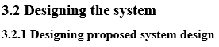

* In system architecture, models and diagrams like class diagrams, sequence diagrams, and use case diagrams help illustrate the logical flow of a system. They provide visual representations that allow users to understand the system's functionality, interactions, and structure effectively.

**1.3.2.2 Designing the user interface for the suggested system.**

* The utilization of software solutions for constructing a graphical user interface is a key aspect of this stage. It involves the development of a system prototype, wherein the visual representation and user interaction elements of the proposed system will be showcased and evaluated.

**1.3.2.3 Designing the proposed system database**

* The modeling of the system's database is a crucial step in this phase. It involves analyzing the entities and their associations, which will be depicted in an entity relationship diagram, providing a visual representation of the database structure.

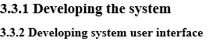

* The system interface plays a crucial role as the front end of the system, enabling users to establish communication with the system's backend. This interaction will provide users with access to the system's features and facilitate seamless engagement with the system.

**1.3.3.3 Developing system database**

* The system will incorporate a dedicated database to store the records generated by the system's actors. This database will serve as a reliable and centralized storage solution, ensuring the secure and efficient management of data produced within the system.

**1.3.3.4 Developing system functionalities**

* The development phase will involve the creation of functions for the proposed system, aiming to enhance its practicality and significance. These functions will be carefully designed and implemented to provide users with expanded functionalities and improved overall system performance.

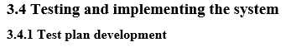

* In this section, the criteria for testing the complete system are outlined, which will be used to evaluate its conformance to the mentioned functionality. These criteria play a vital role in assessing the system's performance and ensuring its alignment with the specified requirements and functionality.

**3.4.2 Testing system functionalities**

* At this stage, unit testing will be carried out to make sure every functionality has been covered by the test plan that will be developed.

**3.4.3 Reviewing and fixing errors**

* After the system has been tested and some errors have been discovered, those errors will be examined to make sure that those that can be fixed are fixed.

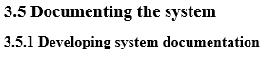

* This will be a document that outlines and clarifies every step of the project.

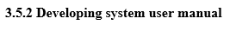

* This document will be made to act as a manual for system users. In order to better assist users in understanding the system, this document will further define the procedures for using and executing various capabilities.

**1.3.5.3 Producing test logs**

* This is a document that will be made to outline the testing procedures used for the system and the evaluations that were made.

1.4 Approach

To attain excellence in system development, multiple methodologies must be used, and the success of any system development project is dependent on excellent process management. A methodology in software development is a set of steps that guides the planning, organizing, coordination, and oversight of information system production (Asmo, 2018). Various software development methodologies were used on this project, with the Object-Oriented methodology emerging as the most effective foundation.

The Object-Oriented methodology has features that put it ahead of other methodologies, making it suited for projects of varied sizes. R.H. Half (2017) discussed the benefits of this methodology in the context of software development. The methodology, in particular, makes it easier to reuse system modules, components, and parts throughout the development process. The methodology instills trust in generating a high-quality system with minimal component maintenance expenses due to its ability to simulate real-world conditions.

The Object-Oriented approach includes three key phases in software development: Object-Oriented Analysis, Object-Oriented Design, and Object-Oriented Implementation (Tutorialspoint, 2021). Each of these phases includes tasks such as developing a research problem, defining user requirements, incrementally designing the system model and objects based on the requirements collected, and translating the system model into code that materializes as a tangible deliverable via an appropriate programming language.

This methodology's incremental development encourages the progressive introduction of software, reducing the danger of developing complications while giving a systematic approach that is easily understandable to the target audience. This increases the software's feasibility, making the Object-Oriented technique a solid choice at the heart of this development approach.

### Justification of the Chosen Methodology for the Project

The object-oriented methodology was evaluated and selected as the foundation for this project for various compelling reasons. One important aspect is its ability to accelerate development by permitting the reuse of existing system objects and aiding the timely construction and deployment of a functional deliverable within the project's defined deadline. Furthermore, the methodology's ability to simulate real-world circumstances improves its usability, making it easily understandable and adaptable for the intended stakeholders. Another important factor in its selection is the methodology's adaptability to changes during the development process. The capacity to obtain input from project supervisors and integrate necessary revisions is specifically adapted to this project and matches nicely with the features of the Object-oriented methodology.

1. Literature Review

## 2.1. Approach to literature searching

Following this exploration of literature, various technological solutions and systems akin to the proposed dermatology management system will undergo evaluation based on diverse criteria. The aim is to determine the optimal approach for developing a tailored and effective system for dermatological management. By examining published articles on dermatology management systems, a deeper understanding of the limitations and deficiencies prevalent in existing systems is gained. Leveraging numerous first-published journals and articles expedites this assessment process.

Given the project's focus on dermatology, Google Scholar is selected as the platform to augment this study and acquire comprehensive knowledge on the topic. Serving as a research entry point, Google Scholar offers user-friendly navigation, reliability, and contextual understanding of information rooted in scholarly work, making it an invaluable literature source (LIB, 2021). Additionally, being an open platform, Google Scholar provides access to a diverse array of literature sources that can significantly contribute to this endeavor. Notable sources such as Academic Search, IEEE Xplore, and Information Bridge will be utilized to enrich the research.

To investigate systems previously developed by entities or individuals, especially those associated with dermatology management, the widely-used Google Search engine will be employed. As suggested by Adair (2020), considering the limited technological advancements in the dermatological field, this research on dermatology management software necessitates a focus on comparing findings with systems offered by leading vendor industries.

## 2.2. Identifying the problem

Recent insights into dermatological care reveal a rising demand for efficient services to address various skincare issues. A significant challenge in the current scenario is the lack of optimized systems to meet the diverse needs of patients seeking dermatological treatments. This gap in the existing infrastructure hinders the seamless delivery of skincare services.

The proposed Dermatology Management System aims to bridge this gap by introducing a technologically advanced solution to the challenges faced by both practitioners and patients in the skincare domain. Unlike mental health issues, dermatological concerns range from cosmetic to medical, necessitating a system that can cater to a wide spectrum of requirements.

Despite the evident need for quality skincare, current systems often lack the necessary features to streamline the patient experience. Appointment scheduling can be cumbersome, and the absence of centralized patient records makes it challenging for dermatologists to provide personalized treatment plans.

2.3 About Dermatology systems

Tele dermatology, a subset of e-skin therapy, offers a revolutionary approach to dermatological care. It leverages digital communication tools to connect individuals with board-certified dermatologists remotely, providing them with expert advice and treatment options without the need for in-person visits. This innovative method of skincare consultation has the potential to transform the field of dermatology, offering numerous benefits for both patients and healthcare providers.

Research has shown promising results for tele dermatology’s effectiveness. Studies indicate that online skincare interventions can effectively address a range of skin conditions and reduce the severity of dermatological issues. The ability to tailor treatments to individual needs based on specific skin types and concerns enhances the efficacy of tele dermatology, potentially yielding better outcomes compared to traditional in-person consultations (Mohd Noor et al., 2018).

Despite its many benefits, tele dermatology does come with challenges that need to be addressed. Connectivity issues in remote areas can hinder the smooth delivery of online consultations, and technical difficulties may arise for some clients. Ensuring that patients and healthcare providers are comfortable with using technology and that proper data security measures are in place is essential to maintaining patient privacy and protecting sensitive personal information (Jeong et al., 2018).

Overall, tele dermatology represents an exciting advancement in the field of dermatology, offering convenience, improved treatment quality, and increased accessibility to specialized skincare expertise. As technology continues to evolve, it is expected that tele dermatology will play an increasingly significant role in delivering high-quality dermatological care to patients worldwide (Zhao et al., 2022).

As technology continues to advance, skin care systems are becoming increasingly crucial in promoting accessible and effective skincare treatments. The ability to provide immediate access to skincare expertise empowers individuals to take better care of their skin and adhere to personalized skincare regimens. Hale skin clinic, as a skincare brand, recognizes the significance of e-skin therapy and may consider developing a web application to connect its clients with skilled dermatologists, ensuring that they receive personalized and professional skincare guidance conveniently and efficiently.

3. REVIEW OF OTHER SIMILAR SYSTEMS

3.1 Introduction

**Similar Systems**

1. **Skin Version**

**Description:** Skin Version is a comprehensive skin care app designed to cater to users' personalized skin care needs. It offers an array of features, including analyzing skin health, suggesting suitable skincare products, and providing expert advice through a virtual dermatologist platform.

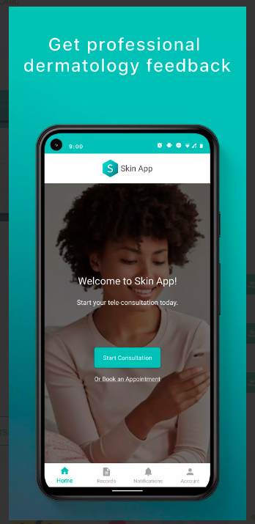

Figure 1 Similar system skin version

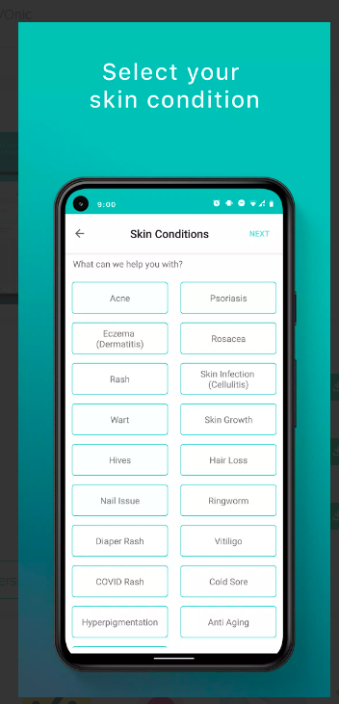

Figure 2 similar system skin version

**Accessibility:**

  - Skin Version is available for both iOS and Android platforms, making it accessible to a wide range of users.

  - The app offers multi-language support, ensuring users from different regions can navigate and understand the content easily.

  - It complies with accessibility guidelines, making it inclusive for differently-abled users, offering features like voice commands and easy-to-read text.

**Navigation:**

  - Skin Version boasts an intuitive user interface, allowing users to navigate the app seamlessly.

  - The app's menu structure is well-organized, with sections for skin analysis, product recommendations, and virtual consultations clearly defined.

  - Users can easily access personalized skincare routines and track their progress through a user-friendly dashboard.

1. **iDoc24**

**Description**: iDoc24 is a dermatology app that enables users to seek medical advice for various skin conditions from certified dermatologists remotely. Users can upload photos of their skin concerns and receive professional evaluations and treatment recommendations.

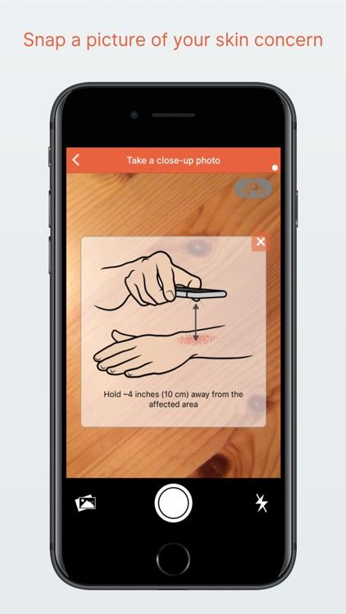

Figure 3 similar system idoc 24

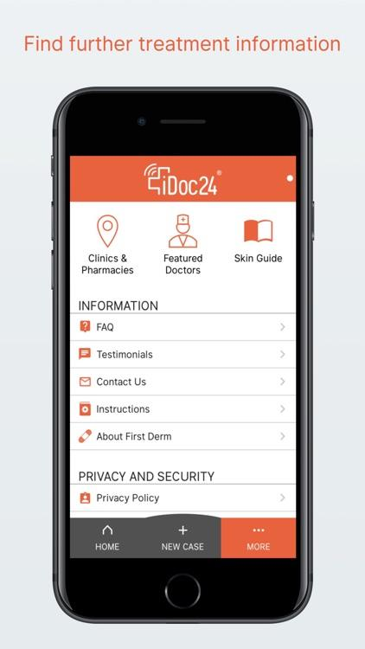

Figure 4 similar system i doc 2

**Accessibility**

  - iDoc24 is available for iOS and Android devices, ensuring accessibility across major platforms.

  - The app offers support for multiple languages, making it user-friendly for a global audience seeking dermatological consultations.

  - Users can create accounts and access consultations with ease, eliminating barriers to entry.

**Navigation**

  - iDoc24 provides a straightforward process for uploading photos and submitting consultation requests, ensuring a seamless user experience.

  - The app's notification system keeps users informed of updates on their consultations, enhancing engagement and user satisfaction.

  - iDoc24's user interface prioritizes clarity, simplifying the navigation process for users seeking professional skin care advice.

1. **First Derm**

**Description:** First Derm is a skin care app that connects users with certified dermatologists for remote consultations and personalized recommendations. Users can upload photos of their skin issues and receive confidential evaluations and advice from medical experts.

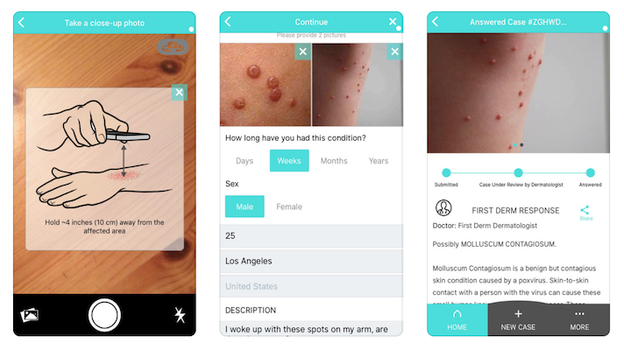

Figure 5 similar system first derm

**Accessibility:**

  - First Derm is available for iOS and Android platforms, expanding its reach to a wide audience.

  - The app supports multiple languages, enabling users from various regions to utilize its services effectively.

  - Users can easily register and create accounts, making the app accessible to new users.

**Navigation:**

  - First Derm offers a user-friendly interface, guiding users through the process of submitting photos and receiving expert evaluations.

  - The app categorizes common skin concerns for easy identification, simplifying the consultation process.

  - Users can view their consultation history and follow-up recommendations effortlessly through the app's organized layout.

1. **Cure Ski**

Description: Cure Skin is an AI-driven skin care app that provides personalized solutions for users' skin conditions. It offers virtual consultations with dermatologists, real-time progress tracking, and recommends dermatologist-approved products.

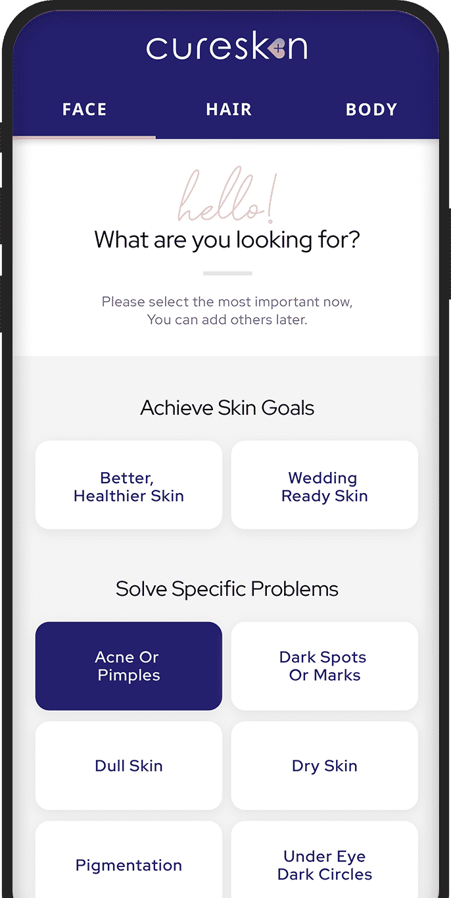

Figure 6 similar system cure skin

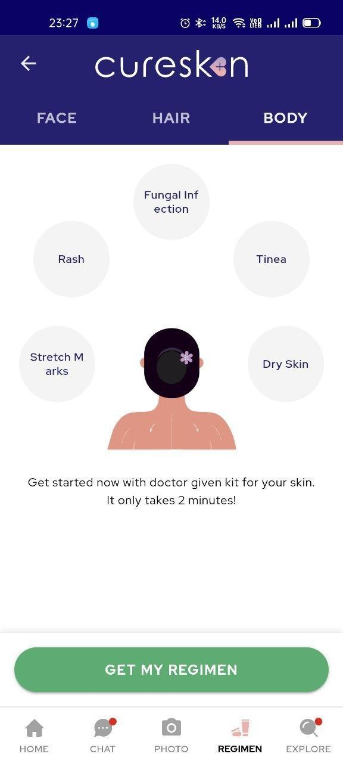

Figure 7 similar skin cure skin

-**Accessibility**

  - Cure Skin is available on iOS and Android, catering to users with different smartphones and devices.

  - The app offers multi-language support, allowing users to access its features in their preferred language.

  - It is designed with an intuitive registration process, making it user-friendly for new users.

-**Navigation**

  - Cure Skin's user interface is designed for ease of use, enabling users to upload photos and answer questions seamlessly.

  - The app's interactive chatbot guides users through the consultation process and provides real-time updates on skin health progress.

  - Cure Skin's dashboard offers users a clear view of their customized skin care routines and treatment plans, making it easy to follow and track their skincare journey.

Conclusion

The analysis of the four skin care apps, Skin Version, iDoc24, First Derm, and Cure Skin, provides valuable insights that will greatly assist in the creation of a skin app for Hale Skin Care Clinic. By thoroughly examining these apps' accessibility and navigation aspects, we can apply the following key takeaways to develop a user-centric and efficient skin care app for the clinic:

1. Accessibility Insights: The assessment of these apps' accessibility reveals the importance of catering to a diverse user base. To ensure inclusivity, the Hale Skin Care Clinic app should be made available on both iOS and Android platforms. Incorporating multi-language support will further enable users from various regions and language backgrounds to access the app easily. Additionally, taking into account accessibility guidelines and implementing features for differently-abled users, such as voice commands and easy-to-read text, will enhance the app's usability and reach.

2. Navigation Enhancements: Analyzing the navigation aspects of the apps highlights the significance of providing an intuitive and user-friendly interface. For the Hale Skin Care Clinic app, organizing menu structures with clear sections for different skin care services, treatment options, and consultations will streamline user interactions. Incorporating a dashboard where users can easily track their progress and access personalized skincare routines will foster engagement and ensure a seamless user experience.

3.Personalized Skin Care Solutions: Learning from the AI-driven and dermatologist-connected features of the analyzed apps like Cure Skin, the Hale Skin Care Clinic app can leverage technology to offer personalized skin care solutions. Integrating AI algorithms for skin analysis and recommending tailored treatment plans will enhance the clinic's offerings and improve customer satisfaction.

4. Virtual Consultations: Taking inspiration from apps like iDoc24 and First Derm, providing virtual consultations with certified dermatologists will be a significant value addition to the Hale Skin Care Clinic App. Allowing users to upload photos of their skin concerns and receive professional evaluations remotely will promote user engagement and establish the clinic's reputation as a reliable and accessible resource for skin care expertise.

# 4. REQUIREMENTS ANALYSIS

The exploration and analysis phase of the system necessitated the utilization of diverse methods for gathering requirements. This aided in delineating and assessing system and user requirements, facilitating the determination of their relevance in alignment with the envisioned system development process.

# 4.2 The method used to gather information

1. **Interviews**

The method of interviewing involves one person asking targeted questions to another individual, resulting in direct responses that revolve around a specific subject. Interviews can be conducted in person or over the phone, and they can involve interviewing a single person or a group of individuals collectively. The advantage of interviews as a data collection method lies in the conversational nature, allowing the interviewee to freely express their thoughts and provide comprehensive insights into the given topic (Kabir & Sajjad, 2016). However, interviews can be demanding for the interviewer as they need to generate follow-up questions swiftly, adapting to the flow of the conversation (Kabir & Sajjad, 2016).

## How the method was used

In order to gather information, at hale skin care clinic the data gathering technique chosen to gather the information was the interview method. This choice was driven by the benefits it provides, including the opportunity to clarify questions as needed and obtain richer insights from the interviewees beyond the limitations of a questionnaire. Specifically, an interview was conducted with the dermatologist from the hale skin care clinic, and the detailed interview questions are provided in the appendix of this document. [See Appendix 1](https://docs.google.com/document/d/1LeEB1IGCD56JNx74OpcgZj4WDE2_BaHd/edit#heading=h.ihv636)

# 4.3 Detailed current system

The current management system in the skin care clinic faces several challenges that hinder its efficiency and effectiveness. One of the major problems is the difficulty in managing appointment schedules and availability. The administrators struggle with manually accommodating rescheduling requests and allocating time slots for appointments, which is a time-consuming process. This manual approach often leads to scheduling conflicts, missed appointments, and overall inconvenience for both the clinic and the clients. Furthermore, the absence of automated reminders and notifications exacerbates the issue, as clients may fail to receive timely appointment confirmations or be informed if the dermatologist becomes unavailable. This lack of communication can result in missed appointments and increased chances of no-shows.

Another significant challenge is the absence of an integrated patient record system. The current system relies on administrators manually handling patient data, which is prone to errors and inefficiencies. This manual process makes it difficult to maintain accurate and up-to-date patient records, including demographics, treatment histories, and outcomes. Without a streamlined and integrated system for managing patient information, the clinic faces challenges in providing comprehensive and efficient care to its clients. The lack of a centralized patient record system also makes it challenging to generate accurate and timely reports for analysis and decision-making purposes.

Additionally, the current system's approach to providing treatment to clients relies heavily on nurses checking in a skin care book to verify symptoms and determine possible diseases. This manual method of diagnosis and medication selection can be prone to errors, leading to incorrect skin diagnoses and inappropriate medication choices. This approach hinders the clinic's ability to provide fast and accurate treatment to clients, potentially affecting their overall skin health and well-being.

# 4.4 Problems with the current system

The current management system at Hale Skin Care faces a multitude of challenges that impede operational efficiency and compromise the quality of client care. One significant issue lies in the cumbersome process of managing appointment schedules and availability. The reliance on nurses referencing a skincare book for treatment decisions poses risks of incorrect diagnoses and medication selection, potentially compromising the effectiveness and safety of client care Administrators often struggle to accommodate rescheduling requests and efficiently allocate time slots for appointments, leading to scheduling conflicts and missed opportunities for client engagement. Moreover, the absence of automated reminders and notifications for clients results in missed appointment confirmations and an increased likelihood of no-shows, contributing to revenue loss and operational inefficiencies. Additionally, the lack of an integrated patient record system necessitates manual handling of data, leaving room for errors and inefficiencies in patient management and treatment planning. Furthermore. These challenges underscore the pressing need for modernization and enhancement of the clinic's management system to ensure seamless operations and optimal client experiences.

# 4.5 Proposed solutions

## 4.5.1 – Available solutions

### 4.5.1.1 – Web Application

Accessible via web browsers, this application supports various devices such as smartphones and laptops, making it highly versatile (Al-Fedaghi & Sabah, 2011). The application is built using programming languages like HTML, CSS, and PHP for its backend functionality. Moreover, it can be developed using other programming languages like Python, JavaScript, or ASP.NET, taking advantage of their respective capabilities. As a web application, the proposed system encompasses all necessary functionalities, including real-time notifications and chat options. This web-based approach offers the convenience of remote access to the system for clients, as long as an internet connection is available. Clients will be provided with a designated link to access the web application seamlessly through their preferred browsers.

### 4.5.1.2 – Desktop Application

After installation, the application runs directly on the computer, eliminating the need for additional resources. Multiple programming languages like C# and C++ can be utilized for its development. Nevertheless, a significant drawback of the application is its requirement for separate versions tailored to different operating systems. For instance, an application designed for Windows would not be compatible with Mac or Linux operating systems. Consequently, clients using operating systems other than the designated version would be unable to access the application on their devices (Zhang et al., 2010).

### 4.5.1.3 – Mobile Application

Clients can download the app onto their smartphones, and it will be developed using Kotlin in Android Studio with support for API 27 and higher. The prevalence of smartphones in the mobile industry means that a vast majority of users own a smartphone. This offers the advantage of widespread accessibility to the mobile app, enabling communication between the client and the psychologist using the device's hardware features. Nonetheless, it is important to note that smartphones have limitations in terms of their compact size and processing speed when compared to web and desktop applications.

# 4.5.1.4 Chosen solution and Justification

Choosing a web application for the development of a skin care system offers several benefits:

1. Wide Accessibility: A web application can be accessed from any device with a web browser and an internet connection. This ensures that users can conveniently access the skin care system from their smartphones, tablets, or computers, regardless of the operating system they are using.

2. Cross-Platform Compatibility: Web applications are platform-independent, meaning they can run on various operating systems such as Windows, macOS, and Linux. This eliminates the need for developing separate versions of the application for different platforms, reducing development efforts and costs.

3. Remote Access: With a web application, users can access the skin care system remotely, enabling them to manage their skin care routines and access relevant information from anywhere with an internet connection. This provides flexibility and convenience for users who may be travelling or on-the-go.

4. Real-Time Updates: Web applications can deliver real-time updates and notifications to users. This allows users to stay informed about their skin care routines, receive reminders for appointments or treatments, and stay updated with the latest information or recommendations from dermatologists or skin care specialists.

# 4.6 System Models

# 4.6.1 Use case of the current

By utilizing the use case diagram, the current system's user interactions will be visually presented, showcasing how individuals engage with the system (Shelly & Rosenblatt, 2012).

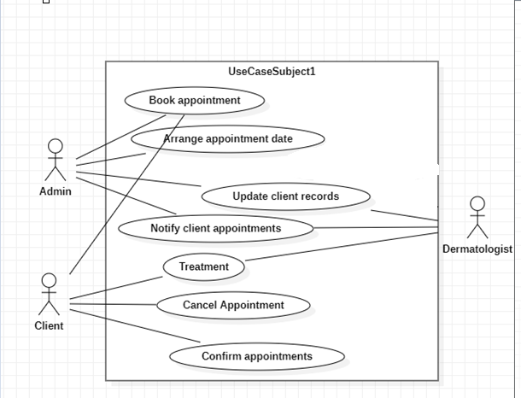

Figure 8 use case diagram current system

Table 1 current system use case description

|  |  |
| --- | --- |
| Use case | Description |
| Book an appointment | The application allows clients to book appointments with dermatologists. |
| Arrange appointment date | The receptionist ensures that appointment dates are set based on the availability of open slots. |
| Notify client appointments | The notification of appointments is done by contacting clients through phone calls after a suitable date has been discovered and established. |
| Update client records | Client records are recorded by the dermatologists and then transferred to the receptionist. |
| Treatment | Clients are checked by the nurse and dermatologist. |
| Confirm appointments | It is necessary for clients to validate their appointment dates and check the available time slots. |

## 4.6.1 – Functional Requirements

This is what the web application will do:

### 4.6.1.1 – Register Clients and dermatologists

The system will be able to register clients and dermatologists, the receptionist will also be able to manage user profiles.

### 4.6.1.2 – Appointment (Booking and Scheduling)

Customers need to be able to schedule appointments with the skin care center. They will be required to furnish their contact information, indicate the preferred date and time for the appointment, specify the dermatologist they wish to consult and provide a brief explanation of the purpose of the appointment. The receptionist manages all appointment operations such as monitoring pending appointments, canceling appointments when necessary, and confirming appointments.

### 4.6.1.3 – Send reminders/notifications

To enhance the client experience and minimize the chances of missed appointments, the application will feature a reminder functionality. Clients will receive timely reminders through email, ensuring they are aware of their scheduled appointments.

### 4.6.1.4 – Skin tracking diagnosis

Dermatologist will have the ability to upload their skin images into the system for analysis. The system will then generate a comprehensive report that assesses the client's skin condition and determine skin symptoms.

### 4.6.1.5 – Produce system reports

Admins will have the option to generate system reports periodically, such as on a weekly or monthly basis this will contain client appointment details. These reports can then be sent to a dermatologist for evaluation and analysis.

### 4.6.1.6 – Treatment

The system should allow the dermatologist to provide a treatment plan for the clients. After the dermatologist has run a diagnosis, the doctor can produce the treatment needed for the determined skin condition.

### 4.6.1.7 – Payments

The system should facilitate a seamless payment process, enabling clients to conveniently pay for their appointments. Admins can utilize this feature to receive payments from clients for scheduled appointments.

### 4.6.1.8 – Video chat

The system should allow clients and dermatogist to interact through a video chat to conduct an appointment. The dermatogist will send a video chat link to the paitent email and the patient will join the video chat.

# 4.7 Non-Functional Requirements.

To ensure the effectiveness and quality of a system, non-functional requirements are a fundamental component of its development. These requirements, which are derived from functional requirements, outline the essential characteristics and attributes that the system should possess. They are commonly known as quality attributes, as they contribute to the overall performance and reliability of the system (Dabbagh & Mohammad, 2015).

**System Security**

The proposed system's primary concern is the security of customer information, as it will handle and store private data. Therefore, it is imperative to establish stringent security protocols and safeguards to ensure that the system remains safe from any unauthorized access or breaches. Protecting the privacy of customer information is paramount to prevent any potential harm or misuse.

**Interoperability**

The system's ability to interface with external systems is essential, considering its reliance on data from diverse sources, such as web APIs. It is imperative that the system exhibits interoperability, enabling efficient communication and integration with these external systems to acquire the necessary data for its operations.

**Availability**

The system's availability is of utmost importance as it aims to provide timely aid to patients during urgent situations. Considering that emergencies can arise unexpectedly, it is crucial for the system to be accessible and responsive whenever a patient is in need.

**Reliability**

The system has a key objective of aiding patients in emergency scenarios. To prevent any challenges, it is essential for the system to execute its designated tasks with precision, adhering to its intended purpose.

# 4.8 Use a case diagram of the proposed system

# 4.8.1 Use a case diagram of the proposed system

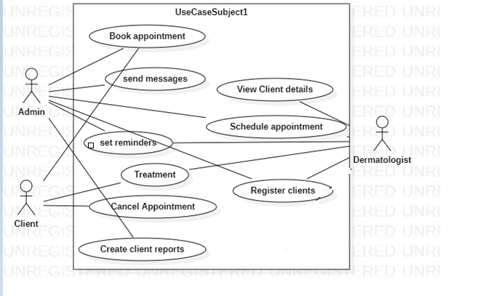

Figure 9 use case proposed system

Table 2 use case proposed system description

| **Use case** | **Description** |
| --- | --- |
| Register clients | The admin can register new users into the system, by adding names, ages, sex, etc. |
| Book Appointment | Clients are be allowed to book appointments through the new system |
| Set reminders | The system will allow the receptionist to set automated reminders for appointments |
| Treatment | The system will allow clients to diagnose skin treatment by themselves. The dermatologist will be able to provide treatment to clients as well |
| Report | The system will allow admins and dermatologists to produce reports on treatments |
| Notification | The system will send email notifications to clients to act as reminders. |
| Schedule appointments | The receptionist will be able to set an appointment schedule automatically |

# 4.9 System Requirements

# 4.9.1 Initial Class Diagrams

In the realm of object-oriented software development, a class diagram serves as a visual representation of the relationships and interactions among classes (Souri, et al., 2011). The proposed system follows an object-oriented approach, with the selected programming language facilitating the implementation of object-oriented principles. The accompanying diagram offers a comprehensive illustration of the classes integral to the development of the proposed system.

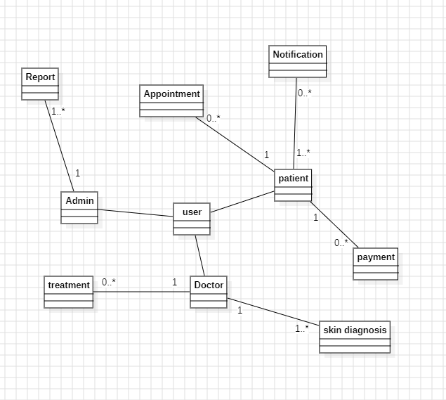

Figure 10 initial class diagram

## 4.9.2 DESIGN STRUCTURE OF THE SYSTEM

A comprehensive system design guideline will be formulated to thoroughly elucidate and illustrate the sequential procedures for crafting a functional system. This entails a meticulous examination of all system requirements during the analysis stage. The document will encompass various system design models, including a detailed class diagram, sequence diagrams, activity diagrams, and the design of the system's database. Additionally, it will offer a succinct overview of the system architecture and outline a test plan for each of the system's features.

# 4.9.2.1 Detailed class diagram

Representing a system's structure at a high level in UML fashion, a comprehensive class diagram displays classes, attributes, methods, and their connections. This static diagram facilitates visualizing, describing, documenting, and generating functionally executable code for the software application. It presents a stable view of the system and illustrates the object model (Al-Fedaghi & Sabah, 2017).

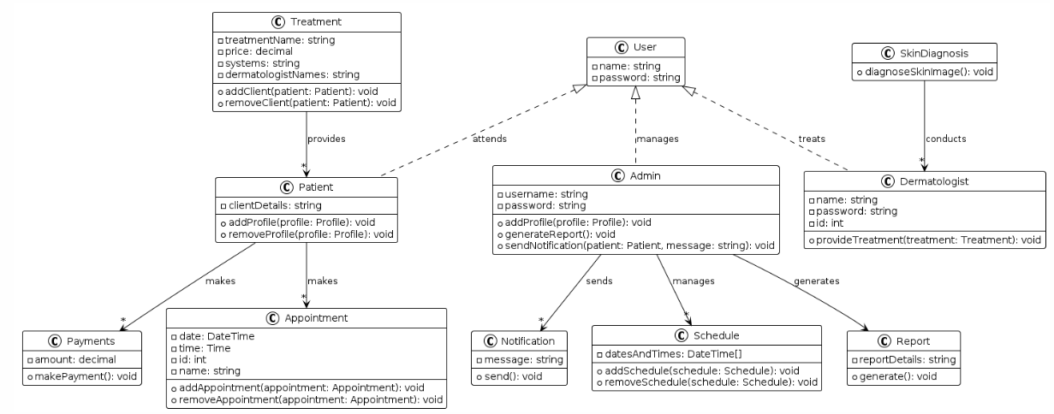

Figure 11 detailed class diagram

The class diagram shown above has been utilized to provide an idealized visual depiction of how the system would be constructed; thereby bearing a set of properties and activities to aid in the system development process.

Class diagram description

|  |  |  |
| --- | --- | --- |
| **Class** | **Description** | **Relationship** |
| User | Represents a system user. | Attends: Connected to Patient, indicating that users attend appointments as patients.  Manages: Connected to Admin, indicating that users with administrative roles manage various aspects of the system.  Treats: Connected to Dermatologist, indicating that users with dermatologist roles treat patients. |
| Treatment | This is a class of counselling treatments, it includes treatment names, price,  systems, dermatologist names | One client can have one too many treatments  One treatment can have zero to many clients |
| Client (inherits from User) | This class represents one of the system users namely the client. The class includes the | One client can have one to zero profiles |
| Skin diagnosis | This class is designed for allowing dermatologist to diagnosis client skin images | One dermatologist can manage one to many skin diagnosis |
| Admin (inherits from User) | The class is designed for the central system user, which is the administrator. Within this class, crucial login information, such as the admin's password and login credentials, is stored. | One admin can have one or  zero profiles |
| Dermatologist (inherits from User) | The class represents a system user, specifically the dermatologist. Within this class, crucial details related to the dermatologist are stored, including their name, passwords, and unique IDs. | One dermatologist can have one to zero accounts |
| Schedule | The class embodies the scheduling functionalities responsible for managing and storing dates and times for appointments. | One admin can manage one to many schedules |
| Appointment | This class serves as a representation of the system appointments, storing crucial information like dates, times, IDs, and names for each appointment. | One client can have one to many appointments |
| Payments | The class represents the client makes a payment for the treatment | One client can make one-to-many payments |

## 4.9.3 Sequence diagrams

Utilized as interaction structures, sequence diagrams illustrate the interconnectedness and order of operations among a set of items. These diagrams visualize the exchange of messages between objects, ranging from module classes to software modules, features, and real-world abstractions (Nikiforova et al., 2015). The provided diagrams portray the sequence of functionalities in the proposed system.

### User Registration and Role Assignment Sequence Diagram

The graphic below demonstrates the system's sequential procedure when creating system users provided by the system administrator.

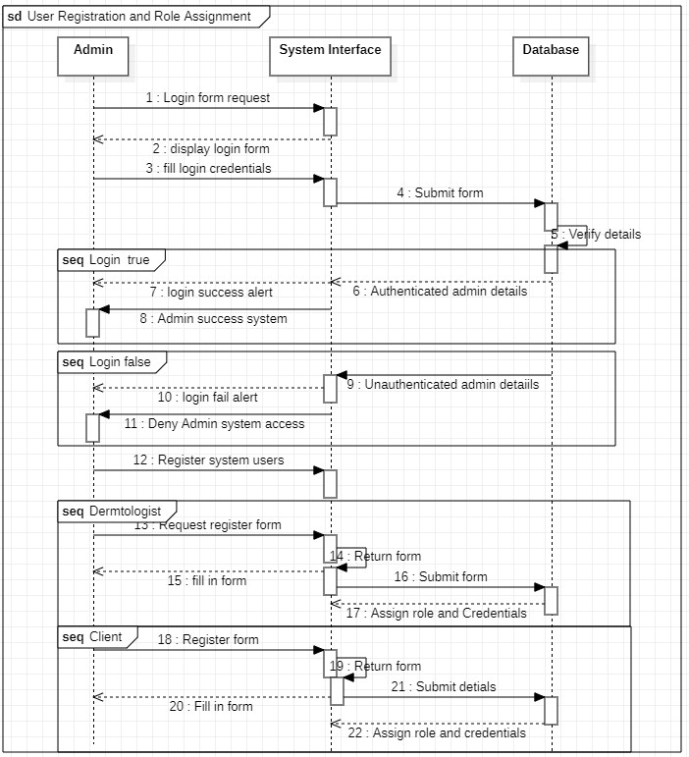

Figure 12 User Registration and Role Assignment Sequence Diagram

Access to the admin panel will be granted to the system administrator using predefined login details. This panel empowers the administrator to carry out various advanced system functions, including the essential task of registering dermatologists.

### Sequence diagram for a client booking

Demonstrated in the diagram is the systematic process by which a client gains access to appointment booking, depicted in a step-by-step manner.

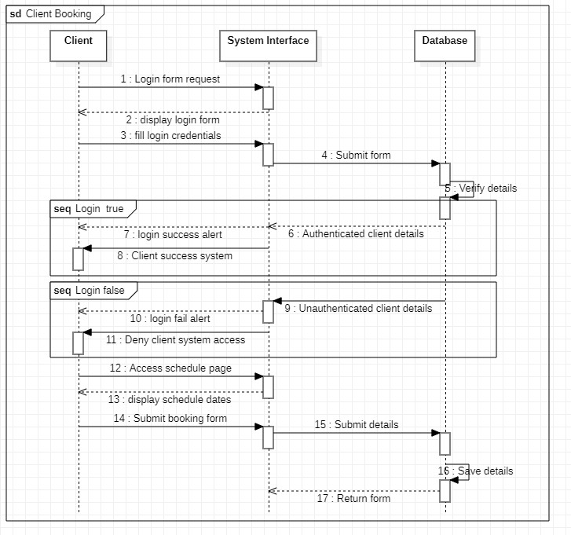

Figure 13 Sequence diagram for a client booking

The system offers two options for client access: registration or login. Upon successful login, the client is directed to the client dashboard, where they can easily navigate to the appointment booking feature. Within the booking page, comprehensive details, including appointment dates, times, and dermatologist information, are presented, simplifying the appointment scheduling process for the client

## Sequence diagram for video chat

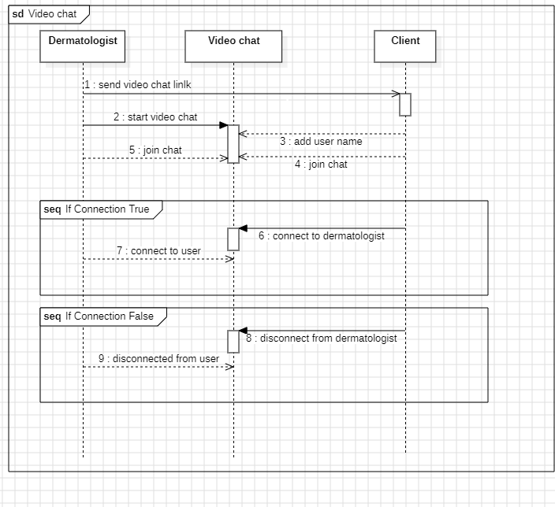

This sequence diagram illustrates the interactions involved in facilitating a video chat session between a client and a dermatologist within the Dermatology Services Management System (DSMS) for Hale Skin Care. The diagram outlines the step-by-step process of initiating, joining, conducting, and concluding a video consultation, leveraging the web application's integrated video chat functionality. Through this seamless communication channel, clients can engage in remote consultations with dermatologists, enhancing accessibility and convenience for both parties. The diagram highlights the coordination between the web application, the Video Chat Service, and the users (client and dermatologist) to establish and manage the video chat session effectively.

## Sequence diagram of client payments

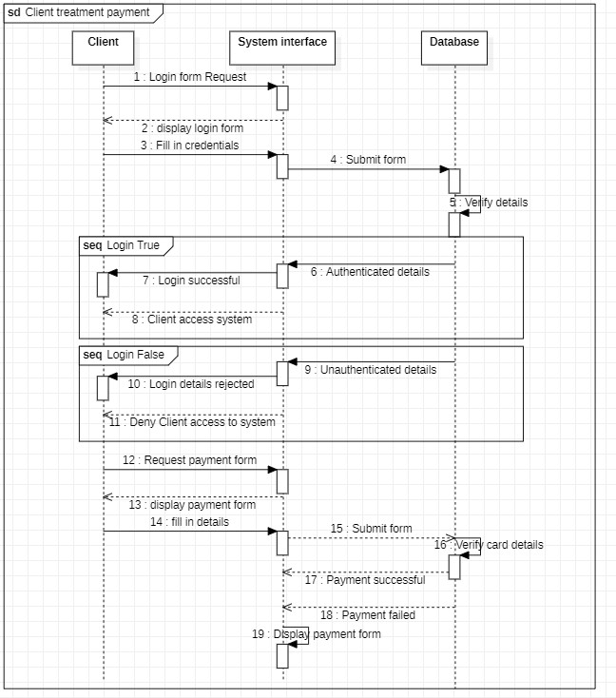

Figure 14 . Sequence diagram of client payments

In the treatment payment sequence, the client starts by logging into the system and accessing the payment page through their dashboard panel. Then, the client enters the necessary payment details. The system processes the payment request by submitting it to the payment gateway for verification. If the provided payment details are valid, the payment is successfully processed. However, if there are any issues with the payment information, the system will display an error message and prompt the client to review and correct the payment details.

### Sequence diagram of dermatologists providing client treatment

The diagram below is a sequence of how a dermatologist provides treatments to clients

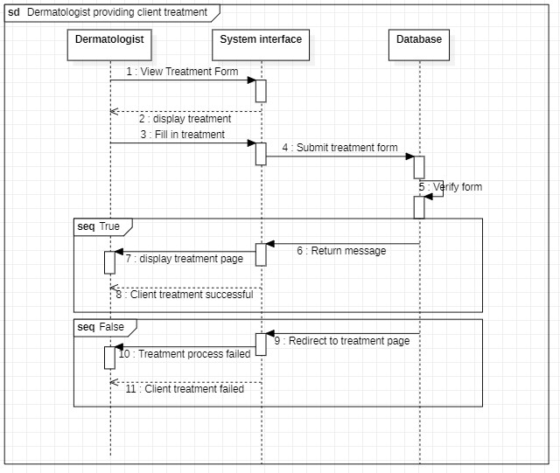

Figure 15 Sequence diagram of dermatologist providing treatment

As a dermatologist providing treatments to clients, you can log into the system and access your dashboard. From the dashboard, you can easily navigate to the treatments menu and click on it to access the treatments page. On this page, you will find all the relevant information about the available treatments that you can offer to your clients. When attending to a client, you can then proceed with the treatment by selecting the appropriate type of treatment from the provided form.

### Squence for a dermatologist skin image upload diagnosis

The diagram below is a sequence diagram of a dermatologist uploading a client’s image to run a skin diagnosis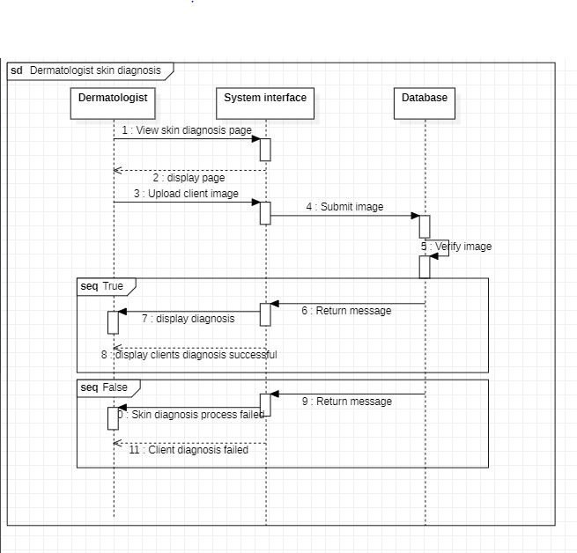

Figure 16 diagram for a dermatologist skin diagnosis

In the skin diagnosis process, the client logs into the system, accesses the dashboard, and selects the "Skin Diagnosis" option. They upload an image of their skin condition, which the dermatologist examines closely. Based on the analysis, the dermatologist formulates a comprehensive diagnosis report and delivers it to the client, providing recommended treatments or further actions for their skin health.

### Squence for a admin generating report

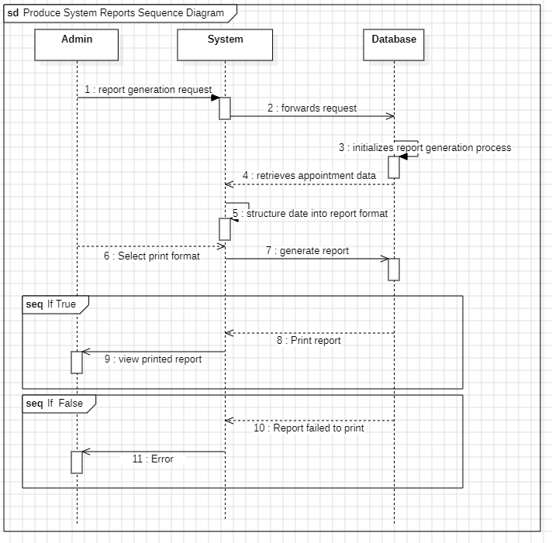

This sequence diagram illustrates the process of generating system reports within the Dermatology Services Management System (DSMS) for Hale Skin Care. It outlines the coordinated interactions between the Admin user, System component, and Database to facilitate efficient report generation. The Admin triggers the report generation request via the web application, prompting the System to initialize the process. The System then queries the Database for appointment details, retrieves the necessary data, and compiles it into a structured report format.

## 4.9.4 Activity Diagrams

As stated by Ericsson and Maria (2017), an activity diagram is a fundamental and intuitive behavioral illustration that depicts the unfolding of a system process. Activity diagrams are valuable in presenting system processes as a sequence of actions. The images provided below depict the activity diagrams corresponding to the proposed system.

### Activity diagram for registering a user

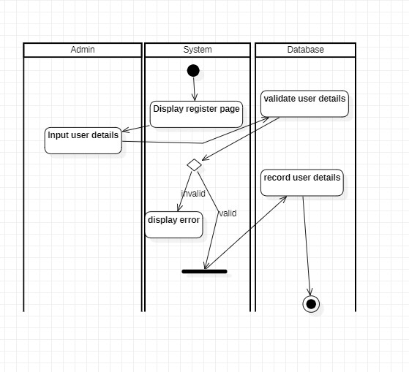

Figure 17 Activity diagram for registering a user

The administrator registers users, which includes inputting the user's information, which might be a client or a dermatologist. Once the details have been filled out and submitted, the system validates them; if the details are correct, they are saved in the database.

### Activity diagram for requesting appointments

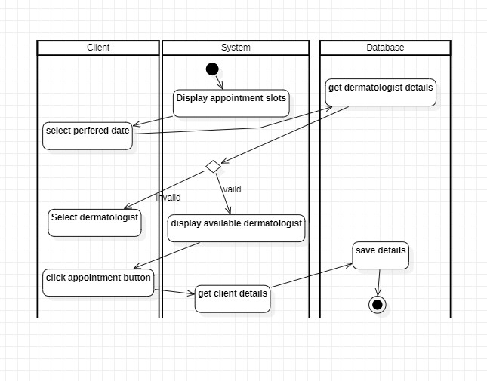

Figure 18 Activity diagram for requesting appointments

The system initiates an appointment request by showing a registered dermatologist to a client. A client then chooses a suitable dermatologist and reviews the psychiatrist's information. If the client is pleased with the dermatologist's profile, he or she should click on Request Appointment, and the information will be submitted to the database and shown to the dermatologist as an appointment request.

### Activity diagram for accepting and rejecting appointments

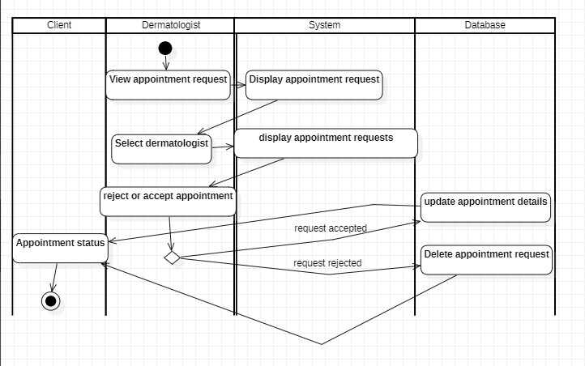

Figure 19 Activity diagram for accepting and rejecting appointments

The dermatologist has the choice to accept or reject appointment requests that have been made after receiving them. The dermatologist first views the appointment requests, which are then displayed. The dermatologist can then select a specific appointment request to view the details. Next, the dermatologist can either accept or reject the request. After the dermatologist takes any action, the client is provided with feedback. He then moves on to schedule if the appointment has been approved.

### Activity diagram for scheduling appointments

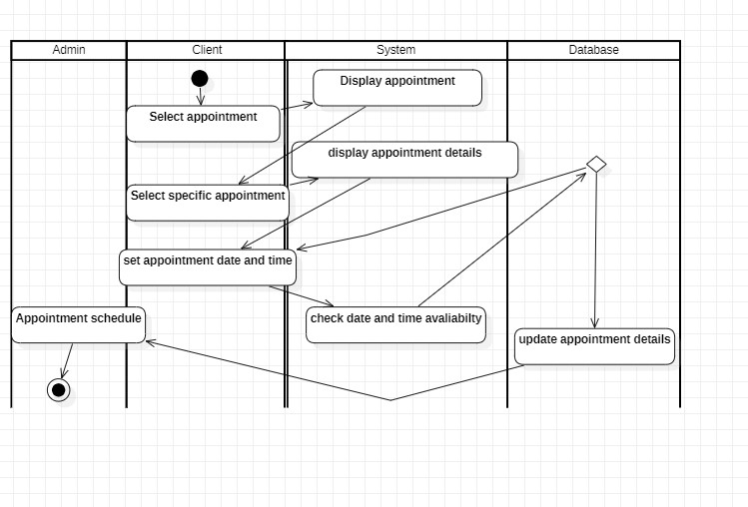

Figure 20 Activity diagram for scheduling appointments

Once an appointment request has been approved, the dermatologist must either choose a day for the appointment or go to the appointments page and choose from among the available times. The dermatologist can set the date and hour of the appointment after viewing the specifics of the selected appointment. If the chosen date conflicts with another, it is suggested that the dermatologist choose an alternative time and date.

Activity diagram for dermatologist providing treatment.

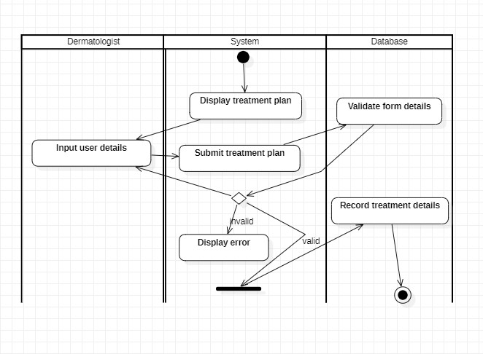

Figure 21 Activity diagram for dermatologist providing treatment

The dermatologist is required to fill in a treatment plan and set the type of treatment they want to apply for the client, the treatment form includes the client’s name, treatment, and type, treatment price. Once the treatment has been made the admin reviews the treatment and processes an invoice for the client to make a payment.

# 5. System Interfaces

The design framework of the envisioned system will be intricately developed to encompass essential components, ensuring alignment with the predetermined user requirements. Through the systematic methodology of system design, the careful projection and visualization will facilitate the creation of a high-quality output for the anticipated system.

## Mid-fidelity Prototype

The mid-fidelity prototype showcases a design that incorporates distinct functional boundaries, yet it integrates clickable elements that visually depict user engagement and offer accessible navigation choices tailored to a specific application.

### Admin dashboard

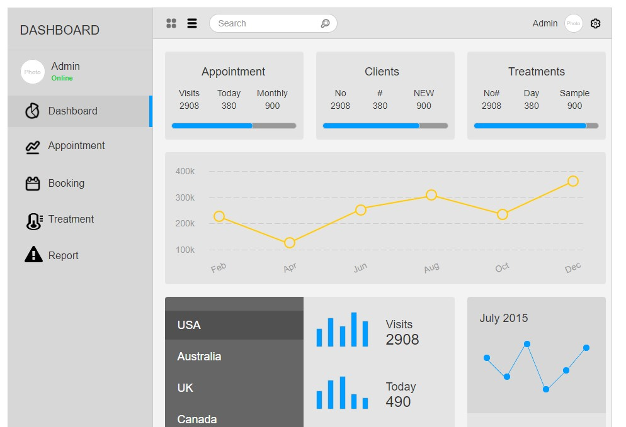

Figure 22 Admin dashboard

The image above is a screenshot of the admin dashboard prototype, the dashboard will be designed to preview some of the recent interactions in the system such as latest appointments, new clients and number of treatments made in the system.

### Admin adding users

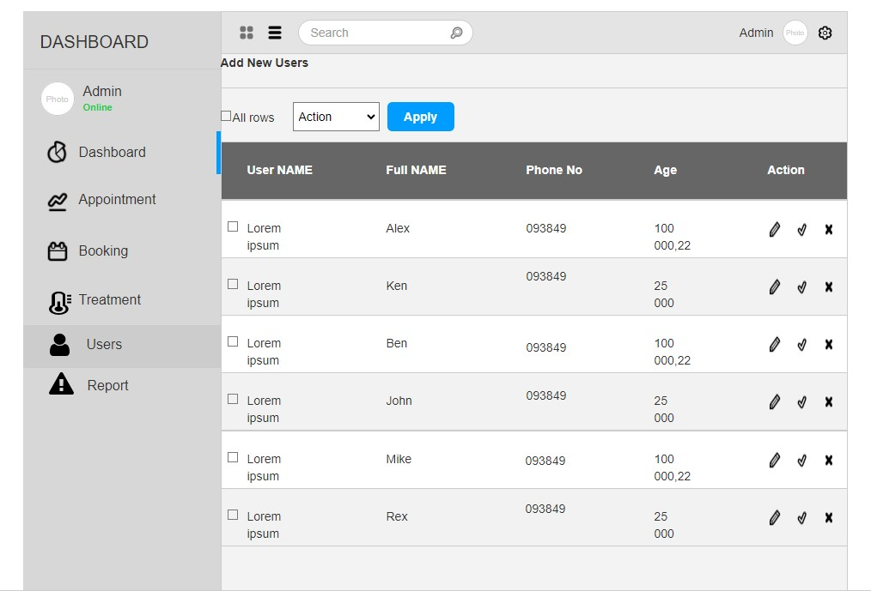

Figure 23 Admin adding users

The image above is the admin user registration page, the admin will be able to manage user profiles in the system.

### Admin Reports

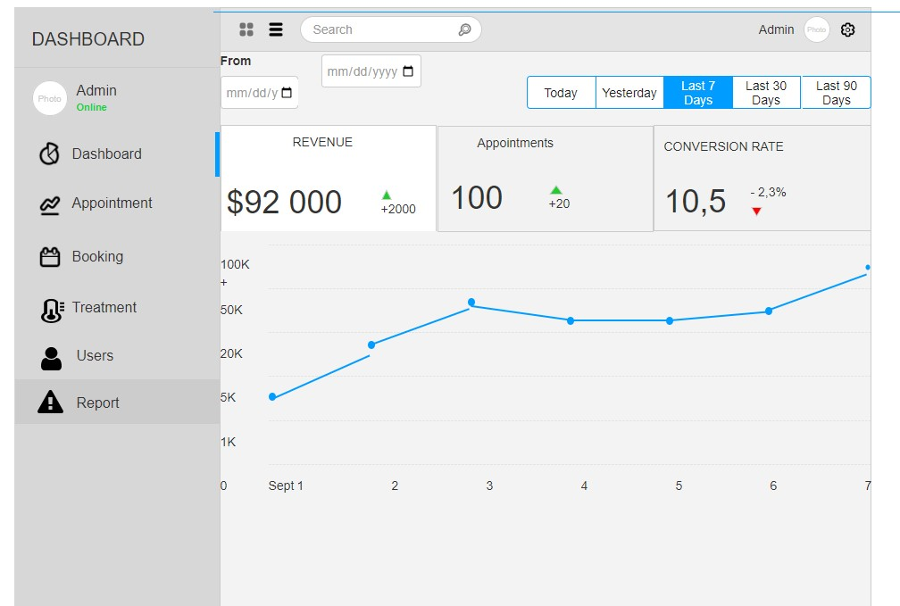

Figure 24 Admin Reports

The image above is the admin system report page, the page will allow the admin to keep track of all reports being made in the system.

### Appointments page

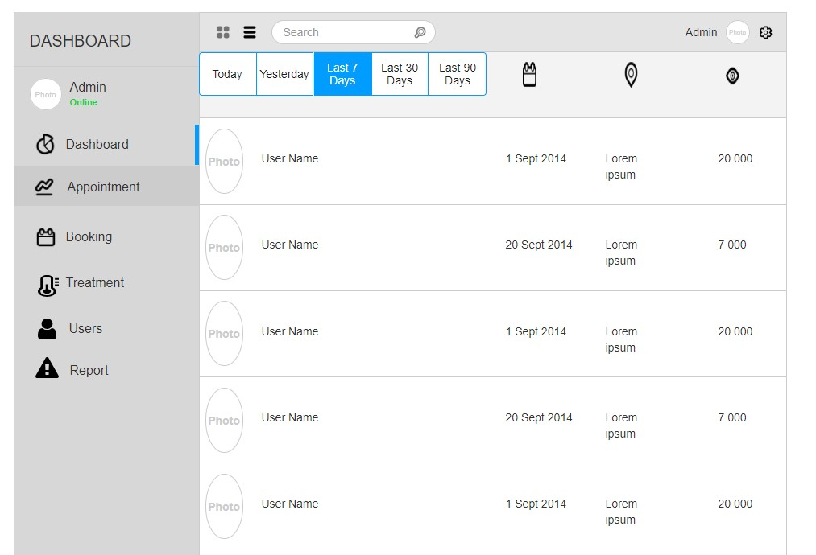

Figure 25 Appointments page

The image above is the admin appointments page, on this page the admin will have access to all the appointments being made in the system.

### Admin payment list

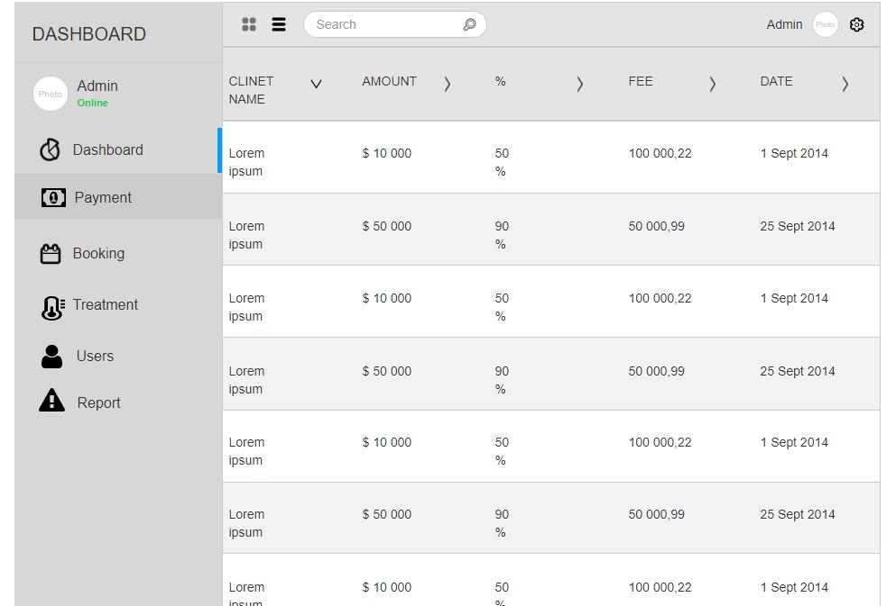

Figure 26 Admin payment list

The screenshot above details the admin panel payment page, on this page the admin will keep track of all the payments to be made in the system.

### User registration

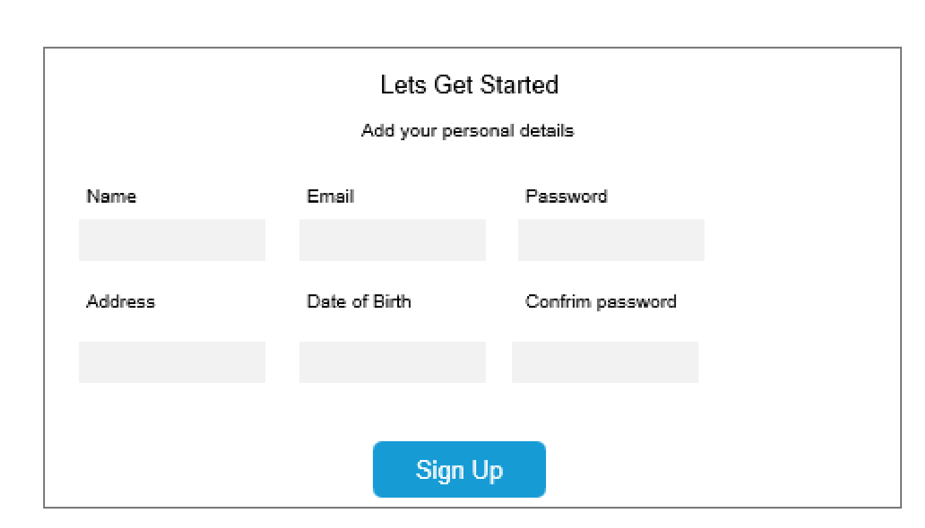

Figure 27 User registration

The image above is a prototype screenshot of the user registration page.

### User payment

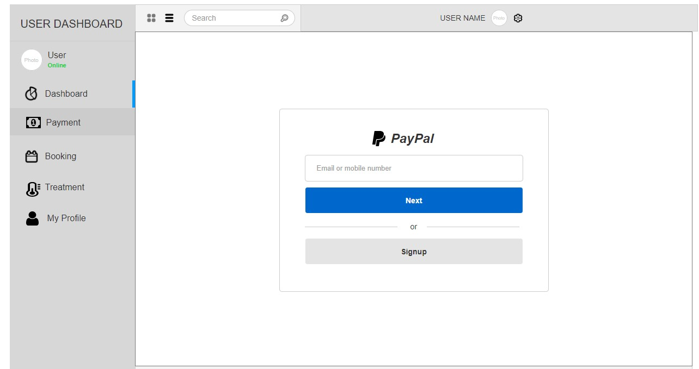

Figure 28 User payment

The screenshot above is the user payment page, when a user gets a treatment plan the user will be required to make a payment.

# 6. 2 Technological Review for the Proposed System.

## 6.2.1 – Chosen Technologies (Platform, Programming language)

## 6.2.1.1 – Platform

Web Application

An application hosted on a remote server and accessible through the Internet using a browser interface is referred to as a Web application or Web app. For its operation, a Web server, application server, and database are essential components. Web servers are responsible for processing client requests, and application servers carry out the necessary actions. To store relevant data, a database may be employed. (Al-Fedaghi, 2011)

Justification

Web applications grant users the convenience of accessing them from any location and at any time, and they exhibit quicker content loading than traditional desktop programs. As these apps reside on servers, users need not possess high-spec computers or smartphones to utilize them. Nonetheless, users may encounter differing experiences due to the varied rendering of the program by different browsers. The overall performance of a web application is dependent on the speed of the internet connection.

### 6.2.1.2 – Programming Language

1. JavaScript is a powerful high-level programming language widely used for website design, web applications, game development, and more. Its dynamic capabilities make it an ideal choice for introducing interactive elements to websites, enriching user experiences beyond the capabilities of HTML and CSS alone.

Justification:

The proposed Dermatology Services Management System (DSMS) for Hale Skin Care will leverage JavaScript to create a user-friendly and responsive web application. JavaScript's versatility will allow seamless integration with various server-side languages, accommodating the diverse technologies used in web servers, such as PHP, Python, Ruby, Java, and .NET.

In the DSMS, JavaScript will handle client-side interactions, providing a smooth and interactive experience for users accessing the web application. Dynamic forms, real-time validation, and responsive layouts will enhance the efficiency and user-friendliness of the appointment booking process. The integration of JavaScript in the proposed DSMS will optimize clinic performance, enhance patient care, and elevate the overall management of Hale Skin Care. Its dynamic features will contribute to a seamless user experience, efficient data processing, and robust functionality, making the DSMS an indispensable tool for dermatology services.

2. PHP is a server-side scripting language widely used for building Static websites, Dynamic websites, and Web applications. Originally known as Hypertext Pre-processor (PHP), it was previously referred to as Personal Home Pages (Jackson, 2022).

Justification:

The proposed implementation of the Dermatology Services Management System (DSMS) for Hale Skin Care will utilize PHP as the server-side scripting language. PHP's cost-effectiveness and cross-platform capabilities make it an excellent choice for deploying applications on various operating systems, including Windows, Linux, and Mac OS. Moreover, PHP's compatibility with different programming languages, such as Java and HTML, enhances its flexibility in creating complex applications. This compatibility allows seamless integration with various technologies and tools, making it easier to develop a comprehensive and adaptable DSMS for Hale Skin Care. PHP's ability to handle server-side operations, such as database connections and data processing, will be leveraged to manage patient records, treatment plans, and other critical functionalities of the DSMS securely. Overall, PHP's features and capabilities align well with the requirements of the proposed DSMS, making it an optimal choice for building a sophisticated and efficient dermatology services management system for Hale Skin Care.

## **– Chosen Tools**

Visual Studio Code

As an open-source offering from Microsoft, this text editor is available for free. It is compatible with a variety of operating systems, such as Windows, Linux, and macOS. Developers can leverage this tool to incorporate and craft new extensions, encompassing code linters, debuggers, and backing for cloud and web development.

Justification

A standout benefit of the program is its support for a broad selection of programming languages, including JavaScript, C++, PHP, and various others. This aspect will play a pivotal role in the project, enabling the incorporation of multiple languages in the development of the proposed system.

Fire fox

This open-source web browser program, Firefox, serves as a gateway to access the World Wide Web and interact with web-based applications. Firefox offers numerous advantages, one of which is its status as a cross-platform browser. This means that different versions of the browser are designed to work seamlessly on various computers, smartphones, and operating systems.

Justification

Mozilla Firefox will play a crucial role in enhancing the performance of the web application to be developed, while also providing a compatible environment for utilizing all technologies, including PHP, JavaScript, and more.

Xamp Server

XAMPP (short for "Cross-platform, Apache, MySQL, PHP, and Perl") is a comprehensive program stack that bundles together several essential software components. When installing XAMPP, it automatically sets up Apache, MySQL, and PHP, among other tools. Operating as a virtual server on your computer, XAMPP provides a convenient environment for web development and testing. This free and open-source software offers developers a versatile platform for building and deploying web applications locally.

Justification

With XAMPP, developers can thoroughly test various web applications and websites locally before deploying them live. This ability to test projects in a local environment allows for greater confidence and fine-tuning before making them publicly accessible using XAMPP.

# 6.4 Database Design

A database is a logically interconnected compilation of data that can be conveniently updated and altered. The presence of a database is crucial for the system, as it serves as the repository for all system data.

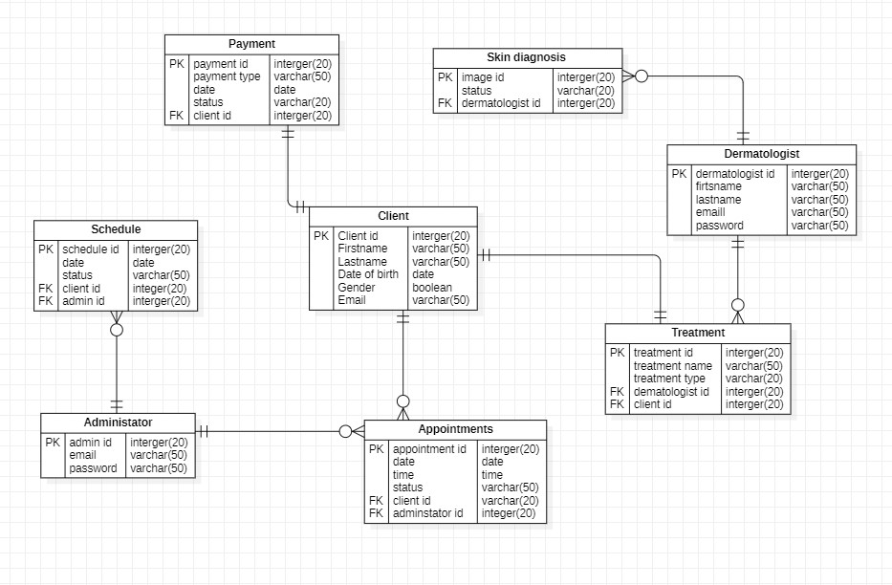

# 6.4.2 Data Dictionary

**Client table**

Table 3 data dictionary client table

|  |  |  |  |
| --- | --- | --- | --- |
| **FIELD** | **DATA TYPE** | **NULL** | **KEY** |
| Client ID | Integer | Not Null | PRIMARY KEY |
| First name | Varchar (50) | Not Null |  |
| Last name | Varchar (50) | Not Null |  |
| Date of Birth | Varchar (50) | Not |  |
| Email | Varchar (50) | Not Null |  |
| Gender | Boolean |  |  |
| Phone number | Numeric (20) |  |  |

**Dermatologist table**

Table 4 data dictionary dermatologist table

|  |  |  |  |
| --- | --- | --- | --- |
| **FIELD** | **DATA TYPE** | **NULL** | **KEY** |
| Dermatologist ID | Integer | Not Null | PRIMARY KEY |
| First name | Varchar (50) | Not Null |  |
| Last name | Varchar (50) | Not Null |  |
| Specialty | Varchar (50) | Not Null |  |
| Phone number | Numeric (10) |  |  |
| Email | Varchar (50) | Not Null |  |

**Appointment table**

Table 5 data dictionary appointment table

|  |  |  |  |
| --- | --- | --- | --- |
| **FIELD** | **DATA TYPE** | **NULL** | **KEY** |
| Appointment ID | Integer | Not Null | PRIMARY KEY |
| Appointment Date | Date | Not Null |  |
| Appointment Time | Time | Not Null |  |
| Appointment Status | Varchar (10) | Not Null |  |
| Client ID | Integer | Not Null | FOREIGN KEY |
| dermatologist ID | Integer | Not Null | FOREIGN KEY |

**Schedule table**

Table 6 data dictionary schedule table

|  |  |  |  |
| --- | --- | --- | --- |
| **FIELD** | **DATA TYPE** | **NULL** | **KEY** |
| Schedule ID | Integer | Not Null | PRIMARY KEY |
| Schedule Date | Date | Not Null |  |
| Schedule Status | Varchar (10) | Not Null |  |
| Client ID | Integer(20) | Not Null | FOREIGN KEY |
| Administrator ID | Integer(20) | Not Null | FOREIGN KEY |

**Treatment table**

Table 7 data dictionary treatment table

|  |  |  |  |
| --- | --- | --- | --- |
| **FIELD** | **DATA TYPE** | **NULL** | **KEY** |
| Treatment_ID | Integer (50) | Not Null | PRIMARY KEY |
| Treatment_Date | Date | Not Null |  |
| Treatment_name | Varchar (10) | Not Null |  |
| Client_ ID | Integer(20) | Not Null | FOREIGN KEY |

**Payment table**

Table 8 data dictionary payment table

|  |  |  |  |
| --- | --- | --- | --- |
| **FIELD** | **DATA TYPE** | **NULL** | **KEY** |
| payment_ID | Integer (50) | Not Null | PRIMARY KEY |
| payment_Date | Date | Not Null |  |
| payment_type | Varchar (10) | Not Null |  |
| Client_ ID | Integer (20) | Not Null | FOREIGN KEY |

**Administrator table**

Table 9 data dictionary admin table

|  |  |  |  |
| --- | --- | --- | --- |
| **FIELD** | **DATA TYPE** | **NULL** | **KEY** |
| Administrator ID | Integer | Not Null | PRIMARY KEY |
| First name | Varchar (50) | Not Null |  |
| Last name | Varchar (50) | Not Null |  |
| Email Address | Varchar (50) | Not Null |  |
| Password | Varchar (10) | Not Null |  |

# 6.5 System Testing

### Test Procedure

During the development of a system, testing is crucial to guarantee the proper functionality of all system elements. The primary testing methods include black box testing and white box testing. White box testing encompasses the examination of input, output, and the actual system code for a defined functional objective, while black box testing solely considers input and output (S. Nidhra, 2016). The system features earmarked for testing encompass client registration, notification transmission, appointment scheduling, reminder requisition for appointments, appointment scheduling, and report generation.

### Test Plan

For assessing a project's system requirements, a test plan serves as a comprehensive system testing guide. Test plans aid in verifying the alignment of all system requirements with the system documentation (indeed, 2021). The following table outlines the test technique employed to assess the functional requirements of the proposed system.

### Integration Testing

To implement this procedure, a segment of the system needs to be developed and incorporated to evaluate its effectiveness and functionality. The data collection feature within the package tracking system serves as an ideal candidate for this integration testing phase. By examining the system's ability to interact with the database and store gathered data, we can ascertain its communication capabilities. This testing phase allows us to verify the performance of specific system components, ensuring they deliver the expected outcomes. Moreover, insights gathered during this phase can guide recommendations for regression testing, ensuring any updates or changes to the system do not disrupt existing functionalities. (Hareton KN Leung, 1990).

Table 10 test plan

|  |  |  |  |
| --- | --- | --- | --- |
| **Item being tested** | **Tester** | **Date** | **Description** |
| Testing the registration of a user | Tinashe Mumba | 29th Apirl 2024 | Testing involves evaluating whether a client can successfully register within the system. Additionally, the process includes verifying if an administrator is able to register a dermatologist. |
| Client getting reminder | Tinashe Mumba | 29th Apirl 2024 | Testing will assess whether a client can receive appointment reminders, specifically focusing on their ability to receive email notifications. |
| Client requesting an appointment | Tinashe Mumba | 29th Apirl 2024 | Testing aims to determine whether a client can effectively choose a preferred dermatologist and subsequently initiate an appointment request. |
| Clients making payment | Tinashe Mumba | 29th Apirl 2024 | Testing will ascertain whether a client can seamlessly join a video chat session with a dermatologist by utilizing a provided link. |
| Scheduling of appointments | Tinashe Mumba | 29th Apirl 2024 | Testing involves verifying whether an administrator can successfully select appointments and define their corresponding dates. The assessment also includes confirming whether the administrator can effectively manage appointments, with the ability to approve or reject them. |
| Skin diagnosis | Tinashe Mumba | 29th Apirl 2024 | Testing will determine whether the dermatologist is able to upload an image and for system to provide a prediction |
| dermatologists creating a video meeting link | Tinashe Mumba | 29th Apirl 2024 | Testing will ascertain whether the dermatologist can proficiently generate and host a live video meeting session. |
| Generating reports | Tinashe Mumba | 29th Apirl 2024 | Testing will determine whether the system can proficiently generate notifications as intended. |
| Generate notification | Tinashe Mumba | 29th Apirl 2024 | Testing will verify whether the system can effectively send notifications to clients as required. |
| Provide for treatment | Tinashe Mumba | 29th Apirl 2024 | Testing aims to confirm whether the system enables dermatologists to offer treatments to clients as intended. |

## Test Cases

To ensure the proper functioning of a system feature, a test case is employed. A test case is a sequential compilation of processes or actions (Hamilton & Thomas, 2022). Comprehensive test cases have been created to validate all the functionalities of the system. For detailed test case results, please refer to the appendix appendix B .

# 8. EVALUATION AND REFLECTION

## 8.1 Lessons learned from undertaking the project

Throughout the entire project development lifecycle, from conceptualization to completion, numerous insights were gained. The project's success hinged significantly on the thorough research conducted before initiation. Without this research, the project would have undoubtedly faced failure, as implementing it confidently, addressing the targeted problem of the current system, would have been exceedingly challenging.

Another key lesson learned was the importance of effective time management and strict adherence to the project's operational schedule and outlined plan. Utilizing a structured approach facilitated the completion of tasks in more manageable segments, aligning with predetermined timeframes, ultimately benefiting the overall project. It also established a robust, direction-oriented framework for efficient time management.

An additional lesson arose during a specific project milestone, where a background literature review of existing systems was deemed essential before commencing any system development. This proved particularly valuable in situations involving the implementation of similar product elements, such as interfaces and system functionalities, offering multiple ideas on approaching the project.

In summary, the most pivotal lesson gleaned from this project experience was the significance of regular feedback from the project supervisor. This process played a crucial role in clarifying the project's trajectory, providing insights from a different perspective, and assessing whether the project was on the right path for success.

## 8.2 What Went Well

The successful implementation of the primary functionality stands out as a significant achievement. The core feature of the system revolves around skin diagnosis, empowering dermatologists to upload client skin images for an insightful analysis of potential skin conditions. The integration of an AI, namely "First Derm," specializing in skin diagnosis, played a pivotal role. This AI-driven functionality, seamlessly incorporated into the system through Python, ensures accurate and efficient skin condition assessments. The robust implementation of this essential feature marks a commendable milestone in the project's success.

The design specification and requirements specification proved to be effective at various stages of the system development. The design phase, in particular, achieved success through collaborative efforts with the project supervisor, resulting in a more organized and comprehensive design structure. The requirement specification phase proceeded seamlessly, benefiting from a detailed gathering of the system's functional requirements, effectively addressing current system issues.

The project supervisor played a crucial role by providing valuable feedback and guidance, instilling confidence in the project's potential for success. The documentation process for this final report unfolded smoothly, as most of the required sections were completed in adherence to the academic standards set by the accredited undergraduate program. This overall positive trajectory in the design, requirements, and documentation phases reflects the diligence and effectiveness of the development process.

## 8.3 What Problems were encountered

The primary challenge faced during the course of the project cantered around the integration of an external API. Since the system heavily relies on a free API function, a notable limitation emerged—the API allowed only 10 trial attempts per day. This restriction proved to be a significant impediment, especially during the crucial development stage of the project's core functionality, notably the integration with an AI-based dermatological diagnostic system known as First Derm.

Additionally, another obstacle arose during the implementation of the payment functionality. Unfortunately, this aspect was not fully completed within the designated timeframe. Consequently, the payment forms were not styled to achieve a visually pleasing appearance. Time constraints played a role in impeding the comprehensive refinement of the payment feature. Despite these challenges, the team aims to address these issues in subsequent phases of development.

## 8.4 How the Current Product might be improved

The current product can undergo substantial improvement by implementing a Dermatology Services Management System (DSMS) tailored to Hale Skin Care's unique requirements. This proposed system would introduce user-friendly online appointment booking, ensuring client engagement and reducing missed visits through automated reminders. Integration of patient records would securely store comprehensive information, facilitating a more organized approach to care. Dermatologists could benefit from creating personalized treatment plans, prescribing medications, and scheduling follow-up appointments, thereby enhancing continuity of care. Automated reporting functionalities would provide valuable insights for informed decision-making and improved clinic efficiency. Enabling online payments, preliminary skin checks through image uploads, and an automated treatment checking method would further enhance the client experience and streamline healthcare processes. Additionally, offering product recommendations post-skin analysis would provide clients with efficient solutions, contributing to heightened satisfaction. Overall, the DSMS implementation holds the potential to optimize clinic performance and elevate the standard of dermatological services at Hale Skin Care.

## 8.5 Further Developments

In considering further developments, the system can incorporate additional features to enhance its functionality and user experience. One potential improvement could be the integration of a secure patient portal. This portal could allow clients to access their medical records, treatment plans, and appointment history conveniently. Implementing telemedicine capabilities for remote consultations can broaden the accessibility of dermatological services. Enhanced communication features, such as a chat system or messaging platform, can facilitate quick and secure interactions between clients and dermatologists. Additionally, incorporating machine learning algorithms into the skin tracking diagnosis functionality can continually improve the system's accuracy and diagnostic capabilities over time. Moreover, expanding the payment system to include various payment methods and integrating it with insurance processing can further streamline financial transactions. Continuous user feedback mechanisms and regular system updates can ensure ongoing improvements aligned with evolving user needs and technological advancements.

# 9. CONCLUSION

In conclusion, the development and implementation of the Dermatology Services Management System (DSMS) mark a significant milestone in addressing the unique needs of Hale Skin Care. The system successfully streamlines clinic operations, providing a user-friendly platform for clients to book appointments, receive reminders, and access personalized medical information securely. The integration of skin tracking diagnosis and treatment planning functionalities enhances the quality of care provided by dermatologists, contributing to improved patient outcomes. The inclusion of automated reports and payment processing further optimizes administrative processes. As we conclude this final year report, it is evident that the DSMS not only meets the current demands of Hale Skin Care but also lays the foundation for future developments in telemedicine, machine learning integration, and enhanced patient engagement. The continuous pursuit of innovation and responsiveness to user feedback will be pivotal in ensuring the sustained success and growth of the DSMS in the dynamic field of dermatological services.

# References

Batten, L., 2022. *2022 Online-Therapy.com Review.* [Online]   
Available at: https://www.e-counseling.com/online-therapy/online-therapy-com-review/  
[Accessed 8 June 2022].

Tee-Melegrito, R. A., 2022. *Talkspace online therapy review 2022.* [Online]   
Available at: https://www.medicalnewstoday.com/articles/talkspace-review  
[Accessed 07 June 2022].

Al-Fedaghi, S., 2011. Developing Web Application. *International Journal of Software Engineering and its Applications,* 5(2), pp. 57-68.

Bolton, D. et al., 2016. INTRODUCTION TO COMPUTER PROGRAMMING(BASIC). Volume 1, p. 2.

Casey, K., 2020. *codersera.* [Online]   
Available at: https://codersera.com/blog/java-vs-kotlin/  
[Accessed 27 May 2021].

Derclaye, E., 2017. What is a Database? *The Journal of World Intellectual Property,* Volume 1, p. 2.

Fayzullaev, J., 2018. *Native-like Cross-Platform Mobile Development Multi-OS Engine & Kotlin Native vs Flutter,* Kouvola: South-Eastern Finland University of Applied Sciences.

Firebase, 2019. *Cloud Firestore.* [Online]   
Available at: https://firebase.google.com/docs/firestore  
[Accessed 22 November 2019].

Flauzino, M. et al., 2018. *Are you still smelling it?: A comparative study between Java and Kotlin language.* Sao Carlos, XII Brazilian Symposium on Software Components, Architectures, and Reuse.

Haber, M., 2016. *Final Report: Java Programming Language. A Simple project to Draw Paint (Java language),* Wuhan: School of Electronic Information and Communications.

Islam, D. M. R. & Mazumder, T., 2010. Mobile application and its global impact. *International Journal of Engineering and Technology,* 10(6), pp. 104-111.

Jackson, P., 2022. *What is PHP? Write your first PHP Program.* [Online]   
Available at: https://www.guru99.com/what-is-php-first-php-program.html  
[Accessed 12 June 2022].

Manhal-Baugus, 2001. The internet, multimedia, and virtual reality impact behavior and society. *E-therapy: practical, ethical, and legal issues. Cyberpsychology & behavior,* Volume 4.

Meg, M., 2019. Application Programming Interface Documentation. *Journal of Technical Writing and Communication,* Volume 1, pp. 4-5.

Microsoft, 2019. *SQL Server 2019: Your modern data platform.* [Online]   
Available at: https://www.microsoft.com/en-us/sql-server/sql-server-2019-comparison#CP_StickyNav_1  
[Accessed 22 November 2019].

Petzold, C., 2016. *Creating Mobile Apps with Xamarin.Forms: Cross-platform C# programming for iOS, Android, and Windows.* 1st ed. Washington: Microsoft Press.

Redko, A., 2015. ADVANCED JAVA: Preparing you for Java Mastery. In: *ADVANCED JAVA: Preparing you for Java Mastery.* s.l.: Exelixis Media P.C, p. 12.

Share, A. E., 2017. Mobile Health. *International Journal of Engineering Research,* 6(11), p. 2.

Tee-Melegrito, R. A., 2022. *Talkspace online therapy review 2022.* [Online]   
Available at: https://www.medicalnewstoday.com/articles/talkspace-review  
[Accessed 07 June 2022].

Zhang, Y., Su, G. & Zheng, W., 2010. Converting legacy desktop applications into on-demand personalized software. *IEEE Transactions on Services Computing,* 3(4), pp. 306-321.

Mohd Noor, Noorhuzaimi & Muhamad, Nur & Sahabudin, Noor & Mustafa, Zuriani. (2018). Development of Skin Care Routine Support System. Advanced Science Letters. 24. 7830-7833. 10.1166/asl.2018.13026.

Jeong, Chang-Won & Joo, Su-Chong. (2018). Skin care management support system based on cloud computing. Multimedia Tools and Applications. 77. 10.1007/s11042-017-5521-0.

Zhao, Jianmei & Wang, Yu & Jiang, Lu & Mu, Yun‐Zhu. (2020). The application of skin care product in acne treatment. Dermatologic therapy. 33. e14287. 10.1111/dth.14287.

Escalé-Besa A, Fuster-Casanovas A, Börve A, Yélamos O, Fustà-Novell X, Esquius Rafat M, Marin-Gomez FX, Vidal-Alaball J. Using Artificial Intelligence as a Diagnostic Decision Support Tool in Skin Disease: Protocol for an Observational Prospective Cohort Study. JMIR Res Protoc. 2022 Aug 31;11(8):e37531. doi: 10.2196/37531. PMID: 36044249; PMCID: PMC9475422.

Al-Fedaghi & Sabah, 2011. Developing Web Application. *International Journal of Software Engineering and its Applications,* 5(2), pp. 57-68.

Borysowich, C., 2010. *Systems Analysis: Interviewing.* [Online]   
Available at: https://it.toolbox.com/blogs/craigborysowich/systems-analysis-interviewing-021411  
[Accessed 21 November 2019].

Dabbagh & Mohammad, 2015. Functional and Non-functional requirements prioritization: an empirical evaluation of IPA, AHP-based, and HAM-based approaches. *METHODOLOGIES AND APPLICATION,* Volume 1, p. 7.

Song, T. T., 2014. *System Analysis and Design - Fact Finding - Observation.* [Online]   
Available at: https://prezi.com/k00ez90bzz5-/system-analysis-and-design-fact-finding-observation/  
[Accessed 21 November 2019].

Kabir & Sajjad, S. M., 2016. Methods of Data Collection. *Basic Guidelines for Research,* Volume 1, pp. 9-10.

Ma & Qiao, 2009. *The Effectiveness of Requirements Prioritization Techniques for a Medium to a Large Number of Requirements: A Systematic Literature Review,* Auckland: Auckland University of Technology.

Peters, C., 2015. *How to Design and Analyze a Survey.* [Online]   
Available at: https://zapier.com/learn/forms-surveys/design-analyze-survey/  
[Accessed 21 November 2019].

Shelly, B, G., Rosenblatt & J, H., 2012. *Systems Analysis and Design.* 9th ed. Boston: Course Technology, Cengage Learning.

Shelly, G. B. & Rosenblatt, H. J., 2012. *Systems Analysis and Design.* 9th ed. Boston: Course Technology, Cengage Learning.

Souri , A., Sharifloo , M. a. & Norouzi , M., 2011. *Formalizing Class Diagram in UML,* s.l.: ReasearchGate.

Waters & Kelly, 2009. Prioritization using Moscow. *Agile Planning,* Volume 1, pp. 1-2.

Zhang, Y., Su, G. & Zheng, W., 2010. Converting legacy desktop applications into on-demand personalized software. *IEEE Transactions on Services Computing,* 3(4), pp. 306-321.

Al-Fedaghi & Sabah, 2017. Diagramming the Class Diagram: Toward a Unified Modeling Methodology. *(IJCSIS) International Journal of Computer Science and Information Security,* 15(9), pp. 1-4.

Ericsson & Maria, 2017. Activity Diagrams: What They Are and How to Use Them.

Hamilton & Thomas, 2022. *Test-case.* [Online] Available at: https://www.guru99.com/test-case.html [Accessed 7 September 2021].

indeed, 2021. *indeed.com.* [Online] Available at: https://www.indeed.com/career-advice/career-development/how-to-write-test-plan [Accessed 12 September 2021].

Nikiforova, O., Kozacenko, L. & Ahilcenoka, D., 2015. UML Sequence Diagram: Transformation from the Two-Hemisphere Model and Layout. *Applied Computer Systems,* pp. 1-3.

S.Nidhra, 2016. Black Box and White Box Testing Techniques - A Literature Review.

*International Journal of Embedded Systems and Applications,* p. 6.

# **Appendices**

## APPENDIX A

**QUESTIONS PRESENTED IN THE INTERVIEW**

The dermatologist at the hale skin Centre was interviewed, and the interview lasted for 30 minutes. The following questions were posed to gather insights into the processes of the current skin care system:

1. When was your skin care center established?

2. What was the primary purpose behind opening a skin careclinic?

3. How satisfied are you with the way your customers receive skin health care?

4. What are some of the challenges you believe patients face when accessing your healthcare services?

5. What are the difficulties encountered by the skin clinic in providing  health care?

6. What methods are currently employed to deliver skin health care to clients?

7. How many dermatologist are available at the skin health clinic?

8. Are you content with the methods utilized to deliver services to clients?

9. What operational issues, such as appointments and schedules, pose challenges for the skin clinic?

10. In your opinion, how can some of the operational issues at the skin clinic be addressed?

11. How do you envision a web application helping your business address its problems?

12. What are the key features you consider crucial for a web application if one were to be developed?

**Appendix (use case)**

This is the key to the use case diagrams that have been shown in this document.

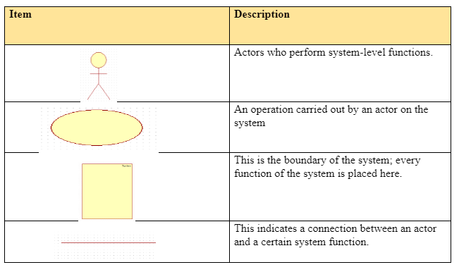

Figure 29 appendix initial class

## **APPENDIX (initial class diagram)**

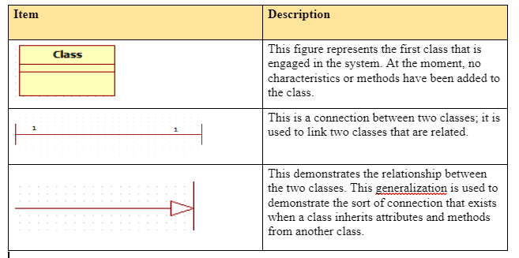

Figure 30 APPENDIX (initial class diagram)

Appendix B – Test case (results)  
To validate the proper functionality of a system feature, a test case is utilized. This test case comprises a sequential series of steps or actions (Hamilton & Thomas, 2022). Comprehensive test cases have been devised for all the system functionalities.

Table 11 test case 1

|  |  |  |  |  |
| --- | --- | --- | --- | --- |
|  | | **Unit Test 1** | | |
| **Tests Case**: Registration of user’s | |  | **Designed by:** Tinashe Mumba | |
| **Data source:** Administrator data entry | | **Objectives:** The system must be able to register users. | **Tester:** Tinashe Mumba | |
| **Test case** | **Description** | **Tasks** | **Expected**  **Results** | **Actual Result** |
| 1 | Entering the user's details and clicking the Register button is the administrator's registration process.  Client registration necessitates the input of their information into the provided registration form. | * Input user details. * Click the Signup button. * Click the Login button | The system needs to have the capability to register all types of users, including clients and dermatologists. | The system is able to register users into the database. |

Table 12 test case 2

|  |  |  |  |  |
| --- | --- | --- | --- | --- |
| **Unit Test 2** | | |  | |
| **Tests Case**: Client getting reminder | | | **Designed by:** Tinashe Mumba | |
| **Data source:** Client data | | **Objectives:** The system should have the capability to provide reminders based on the set date and time within the calendar. | **Tester:** Tinashe Mumba | |
| **Test case** | **Description** | **Tasks** | **Expected**  **Results** | **Actual Result** |
| 2 | The client will be sent an email reminder. | * Select reminder form * Enter the date and time * Click on submit button | The system must be able to connect to google calendar to set reminders of dates and time | The system is able to send clients email reminders |

Table 13 test case 3

|  |  |  |  |  |
| --- | --- | --- | --- | --- |
| **Unit Test 3** | | |  | |
| **Tests Case**: Requesting Appointments | | | **Designed by:** Tinashe Mumba | |
| **Data source:** database | | **Objectives:** Clients should have the ability to initiate appointment requests with their preferred dermatologist. | **Tester:** Tinashe Mumba | |
| **Test case** | **Description** | **Tasks** | **Expected Results** | **Actual Result** |
|  | In the process, clients need to navigate through the list of all registered users, select a dermatologist, and then proceed to request an appointment. | * Browse through the registered dermatologist. * Select a dermatologist. * View dermatologist details. * Click on request appointment with a dermatologist. | The system  effectively initiates appointment requests for clients with their chosen dermatologist. | The system is able to allow clients to book for appointments |
| Table 14 test case 4  **Unit Test 4** | | |  | |
| **Tests Case**: Scheduling Appointments | | | **Designed by:** Tinashe Mumba | |
| **Data source:** Admin input | | **Objectives:** The administrator should have the capability to establish a particular date and time for a specific appointment. | **Tester:** Tinashe Mumba | |
| **Test case** | **Description** | **Tasks** | **Expected Results** | **Actual Result** |
| 4 | The  administrator is required to review appointments, select a specific appointment, and then define the date and time. The recorded data must be stored in the database. | * Browse through appointments. * Select an appointment. * Set the date and the   time for that particular appointment.   * Click on the set   appointment schedule. | The system needs to effectively establish the appointment schedule and inform the client about the designated timing. | The system is able schedule for dermatologist appointments |

Table 15 test case 5

Table 16 test case 6

|  |  |  |  |  |
| --- | --- | --- | --- | --- |
| **Unit Test 5** | | |  | |
| **Tests Case**: Dermatologists creating a video meeting link | | | **Designed by:** Tinashe Mumba | |
| **Data source:** Agora and  Henock | | **Objectives:** A dermatologist ought to have the capability to generate a video chat meeting link. | **Tester:** Tinashe Mumba | |
| **Test case** | **Description** | **Tasks** | **Expected Results** | **Actual Result** |
| 5 | The  dermatologist should have the capacity to generate a meeting link for hosting a video interaction. | * Enter chat name * Click on create enter name * Join chat room * Share attendee link | The system should  effectively generate a meeting link and facilitate the hosting of a meeting. | The system is able to allow clients and dermatologist to run a video chat |
| **Unit Test 6** | | |  | |
| **Tests Case**: Generating reports | | | **Designed by:** Tinashe Mumba | |
| **Data source:** Database | | **Objectives:** System to be able to generate a report | **Tester:** Tinashe Mumba | |
| **Test case** | **Description** | **Tasks** | **Expected Results** | **Actual Result** |
| 6 | The system needs to possess the capability to generate reports derived from the operations conducted within the system. | * Set a date range * Click on generate the report. * Click on print pdf | The system should have the capability to retrieve comprehensive data from the database and subsequently create reports. | The system is able to generate reports |

Table 17 test case 7 and 8

|  |  |  |  |  |
| --- | --- | --- | --- | --- |
| **Unit Test 7** | | |  | |
| **Tests Case**: Make payments | | | **Designed by:** Tinashe Mumba | |
| **Data source:** Database and pay pal | | **Objectives:** The system should possess the ability to make payments | **Tester:** Tinashe Mumba | |
| **Test case** | **Description** | **Tasks** | **Expected Results** | **Actual Result** |
| 6 | The system needs to allow users to make a payment for there appointment using paypal | * Fill in form * Processed to payment * Login into pay pal * Finalise payment | The system should be capable of making payments using pay pal | The system is able to allow clients to make online payments using pay pal |
| **Unit Test 8** | | |  | |
| **Tests Case**: Provide treatment | | | **Designed by:** Tinashe Mumba | |
| **Data source:** Database | | **Objectives:** The system should create client treatment plan | **Tester:** Tinashe Mumba | |
| **Test case** | **Description** | **Tasks** | **Expected Results** | **Actual Result** |
| 8 | The system must allow dermatologist to provide the clients a treatment plan | * Request for counselling * Apply for treatment | The system must be able to retrieve all data from the database and create treatment | The system is able to provide clients with treatments |

Table 18 test case skin diag

|  |  |  |  |  |
| --- | --- | --- | --- | --- |
| **Unit Test 9** | | |  | |
| **Tests Case**: Skin diagnosis | | | **Designed by:** Tinashe Mumba | |
| **Data source:** first derm ai | | **Objectives:** The system should have the capability to run an image skin diagnosis | **Tester:** Tinashe Mumba | |
| **Test case** | **Description** | **Tasks** | **Expected**  **Results** | **Actual Result** |
| 9 | The dermatologist should be capable of running a skin image diagnosis | * Select image * Upload to predict * Submit | The system must be able to provide a prediction for the possible skin condition | The system is able to provide a skin diagnosis |

### Integration Test

|  |  |  |  |  |
| --- | --- | --- | --- | --- |
| **Integration Test** | | **Tests Case: Video connection** | **Test Manager: Tinashe Mumba** | |
| **Data Source: Customer, admin and Application** | | **Objective: Application should be able to connect two different users to a video chat** | **Tester: Tinashe Mumba** | |
| **Test Case** | **Description** | **Tasks** | **Expected Result** | **Actual Result** |
| 1.0 | The system should be able to connect two different users to a video chat room. The users will user a link to join the chat | * The doctor sends the link to the customer through email * Doctor joins meeting room to start chat * Customer joins the chat room | Customers are join meeting through link  Doctors should be able join through link | Both users should be able to join and connect to a chat and meetings |

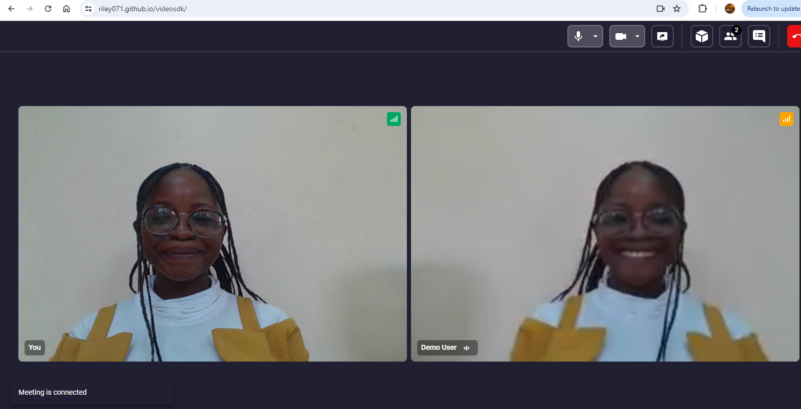

### Integration Test

|  |  |  |  |  |
| --- | --- | --- | --- | --- |
| **Integration Test** | | **Tests Case: Email notification** | **Test Manager: Tinashe Mumba** | |
| **Data Source: Customer, admin and Application** | | **Objective: The objective of integration testing for PHP Mailer is to validate the seamless integration and functionality of the email-sending process within the application.** | **Tester: Tinashe Mumba** | |
| **Test Case** | **Description** | **Tasks** | **Expected Result** | **Actual Result** |
| 1.0 | Integration testing for PHP Mailer involves validating the seamless interaction between the application's email functionality and external email services. The testing process ensures that emails are sent correctly, with the appropriate content, to the designated recipients, and that error handling mechanisms function as expected. | Send a basic email with plain text content to a designated recipient. | The email should be successfully delivered to the recipient's inbox. | The email is sent successfully, and the recipient receives it without any issues. |

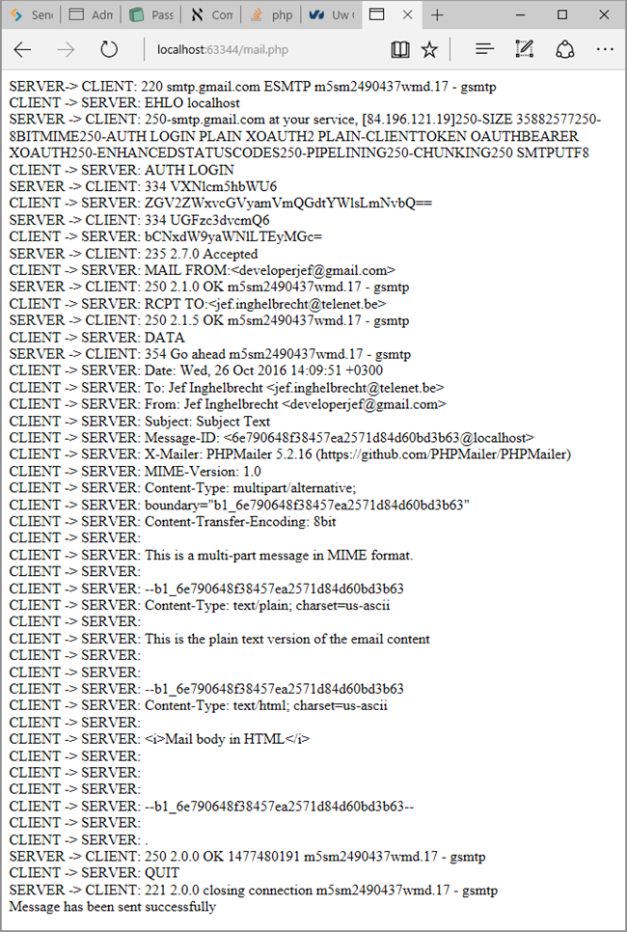

Integration testing for PHP Mailer involves validating the seamless interaction between the application's email functionality and external email services. PHP Mailer, a popular library for sending emails via PHP, ensures the reliable delivery of messages to recipients. Effective integration testing ensures that this crucial aspect of the application functions correctly across various scenarios and conditions.

# APPENDIX C – User Manual Guide

**Admin user manual**

The admin is responsible for carrying several processes, namely generating reports, creating user accounts, managing payments, creating schedules and managing appointments.

Login

In order for admin to login there get to the homa page click on the log in button, fill in the form then login.

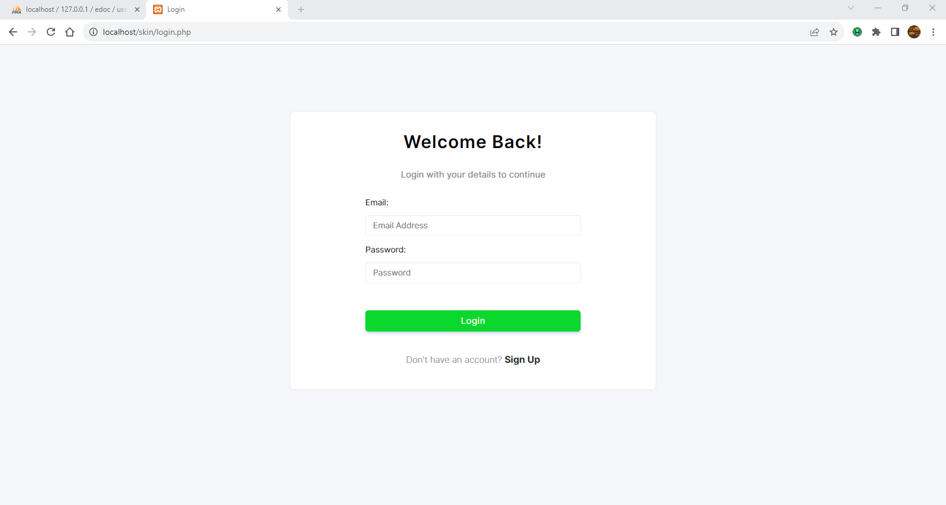

Figure 31 admin

Admin dashboard

If the admin details are valid the system will redirect them to the admin dashboard where they can view recent activates of the system such as upcoming appointments, number of clients, and appointments as well as upcoming schedules.

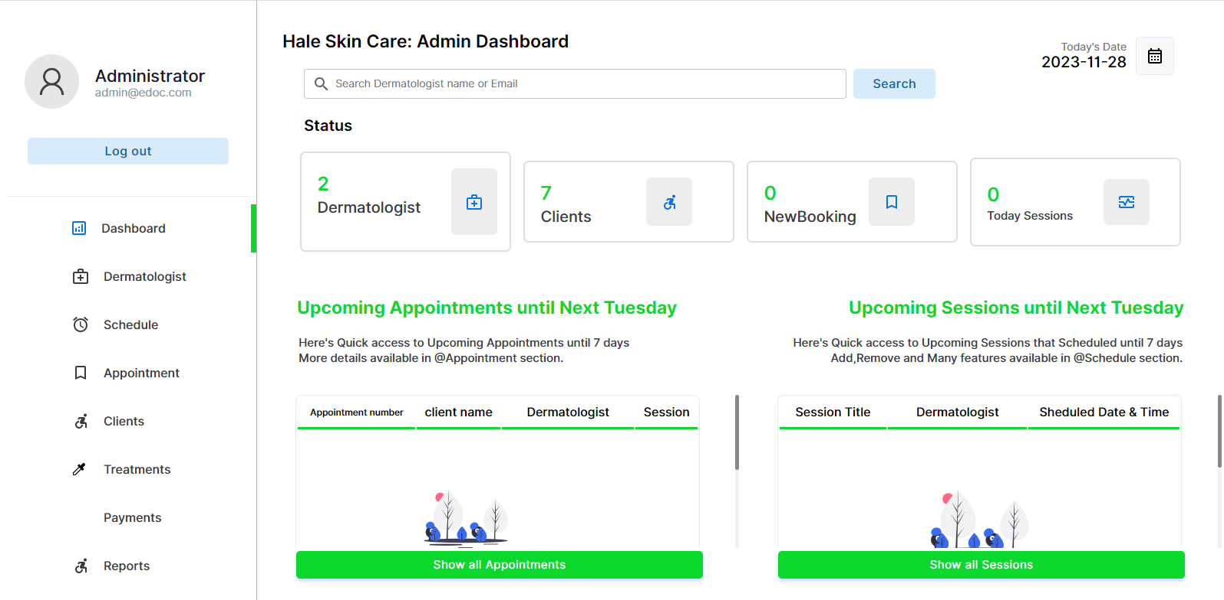

Figure 32 admin dashboard

Admin register dermatologist

Admin is responsible for registering a new dermatologist into the system. The admin can do this task by navigating to the dermatologist page using the side menu and clicking on add new button .

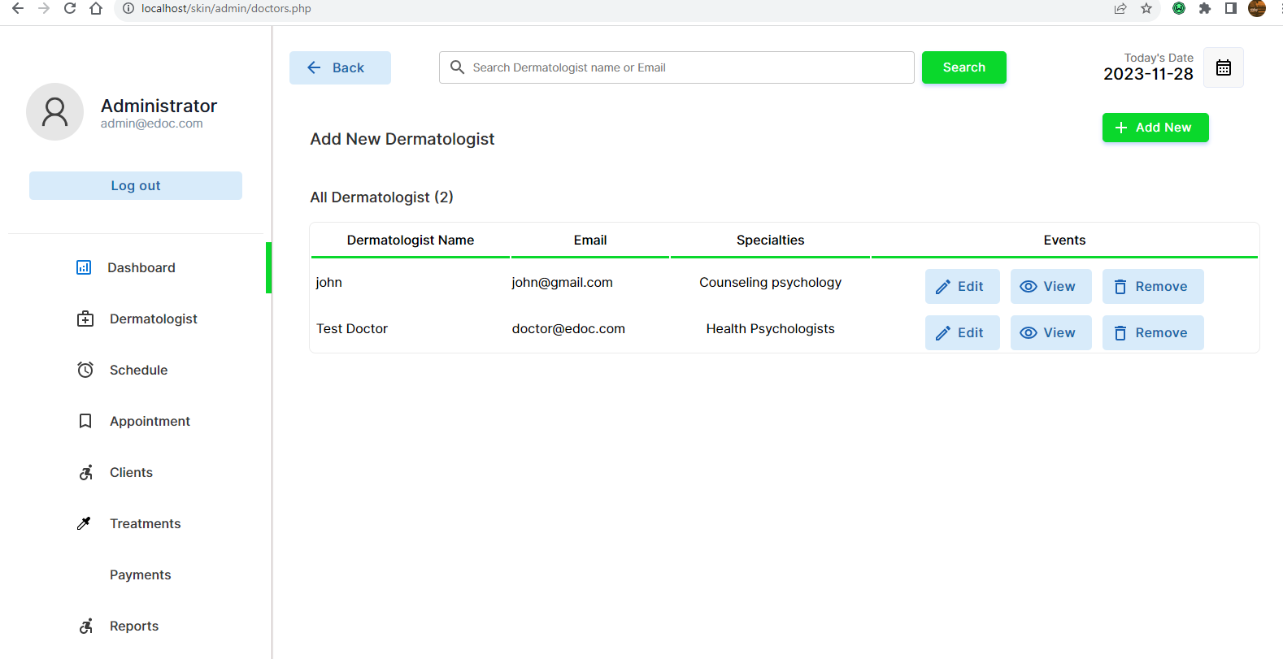

Figure 33 admin register dermatologist

A pop up model will appeal which will ask admin to fill in dermatologist details in order to complete registration.

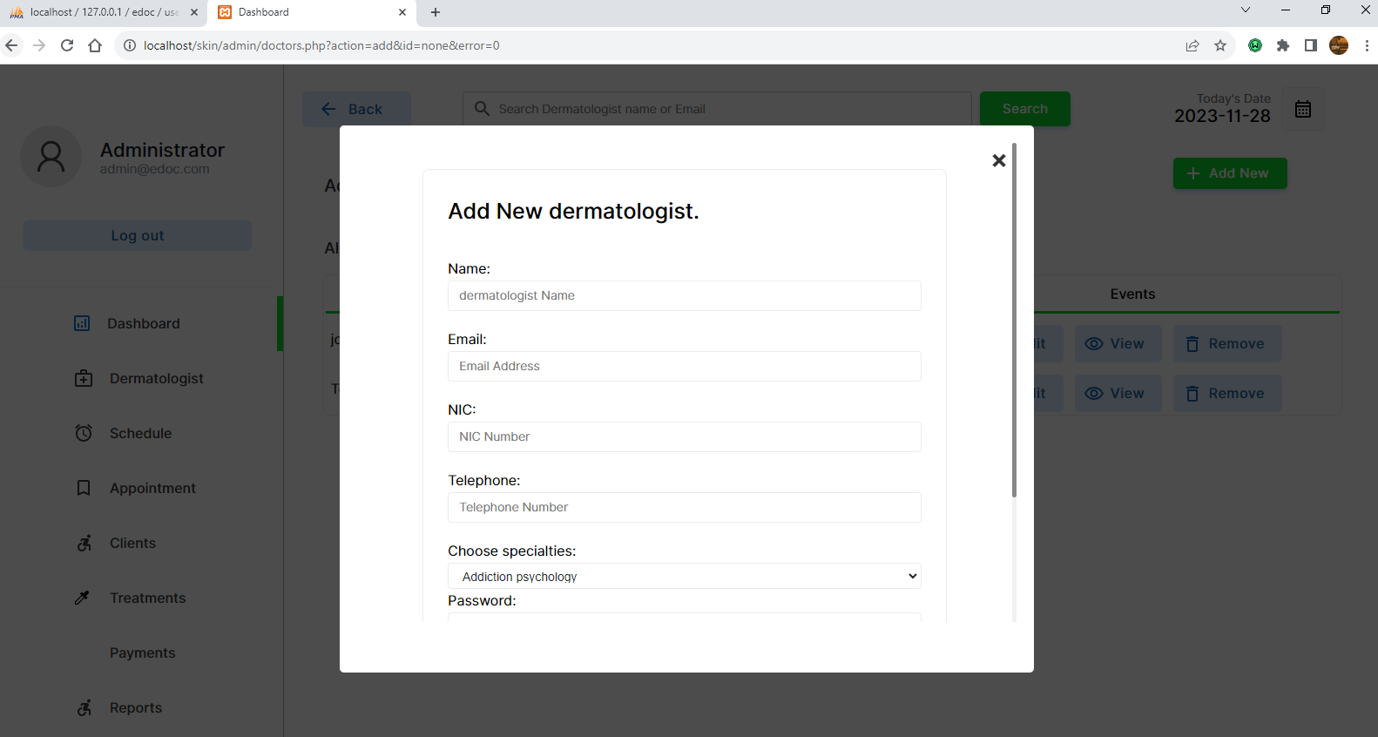

Figure 34 admin add

Admin create schedule

Upon on registering a new dermatologist, the admin is responsible of creating a Schedule for the dermatologist.

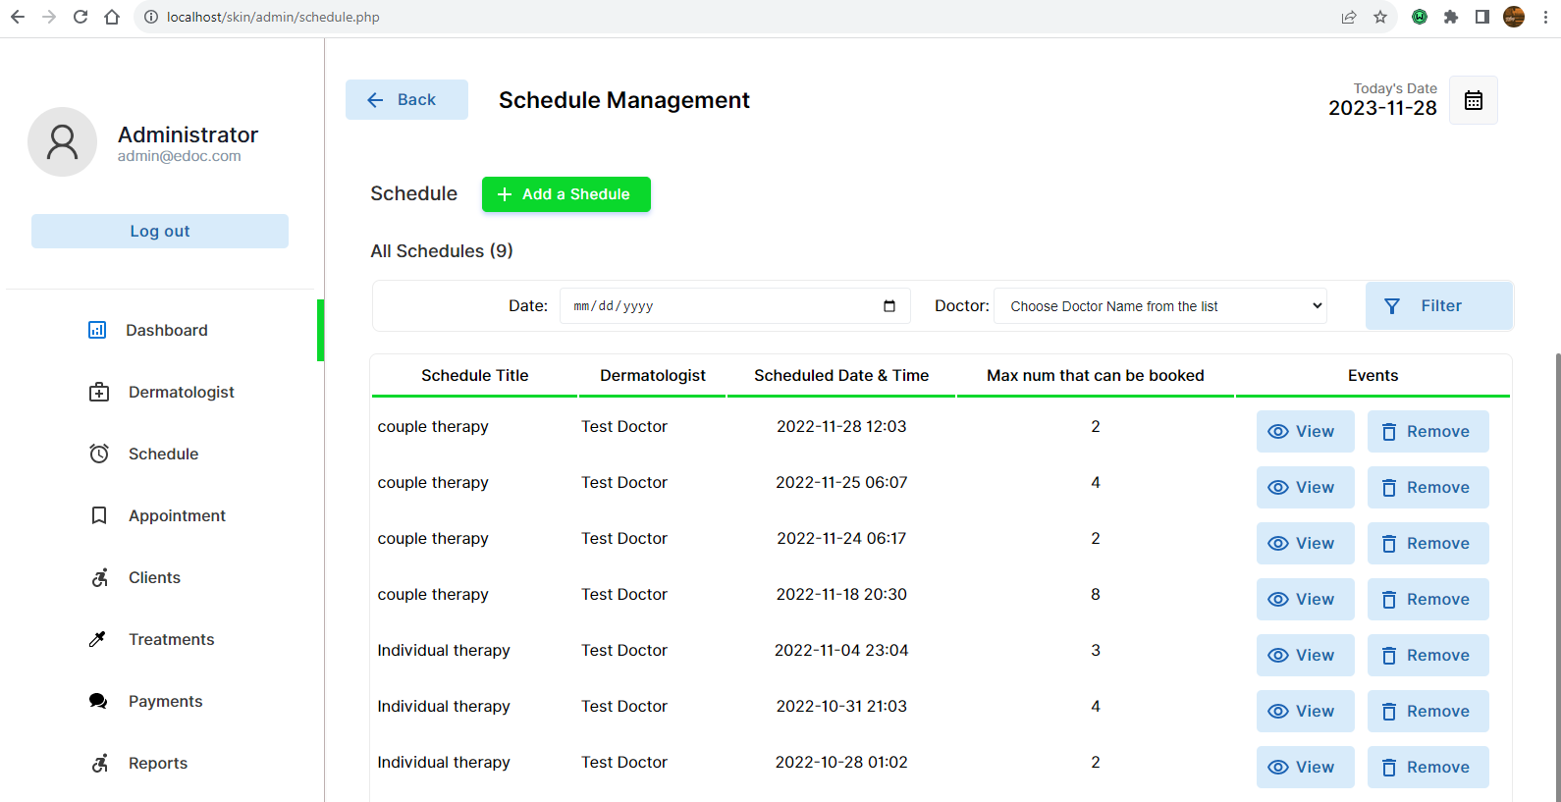

Figure 35 Admin schedule

The system will view a pop model with a form for the schedule details. The admin will fill details and create a schedule for the dermatologist.

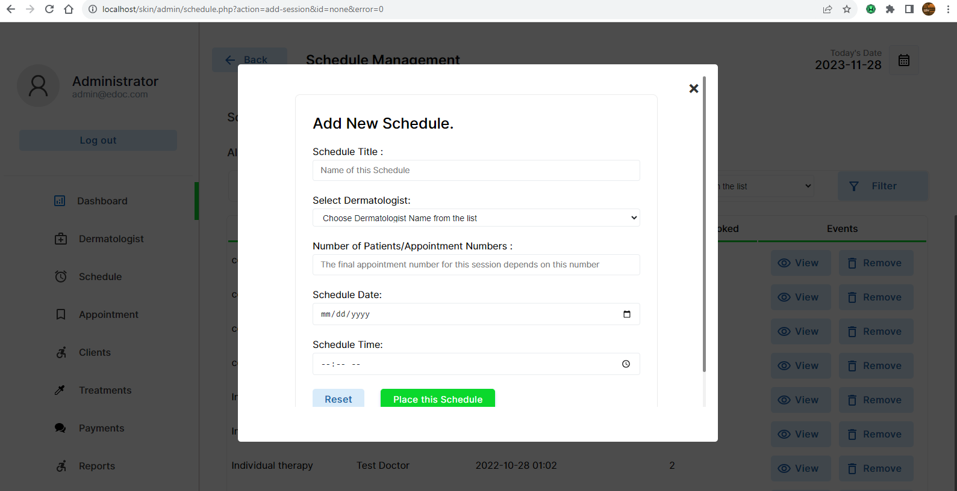

Figure 36 admin create new schedule

Admin manage appointments

The system also allows admins to manage dermatologist appointments , the admin can send clients appointment reminders, through email by clicking the notify button on the appointment page.

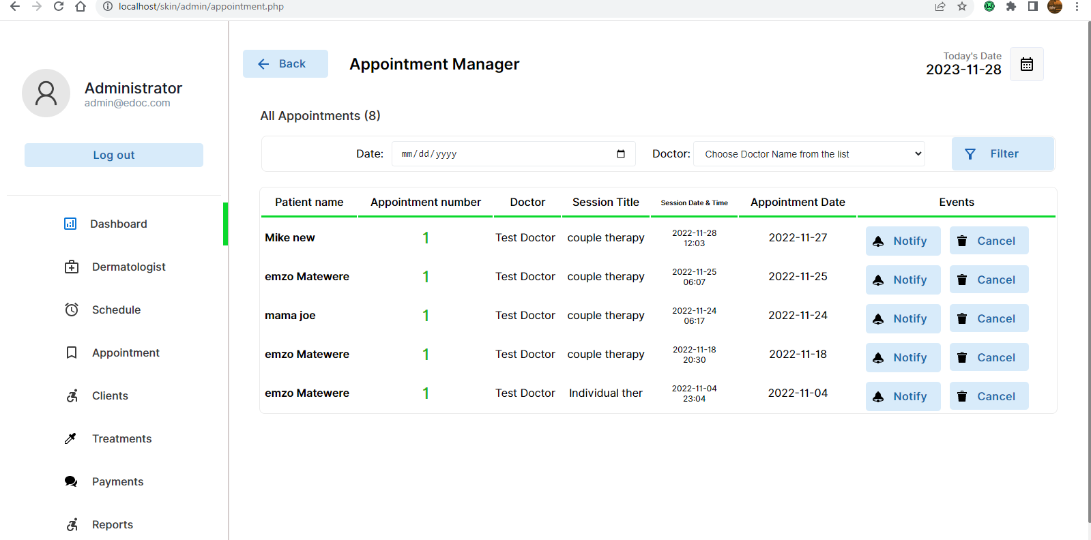

Figure 37 admin manage appointment

Admin send reminder

Upon clicking the button the system will bring a pop model and the admin will click the button to send a client an email.

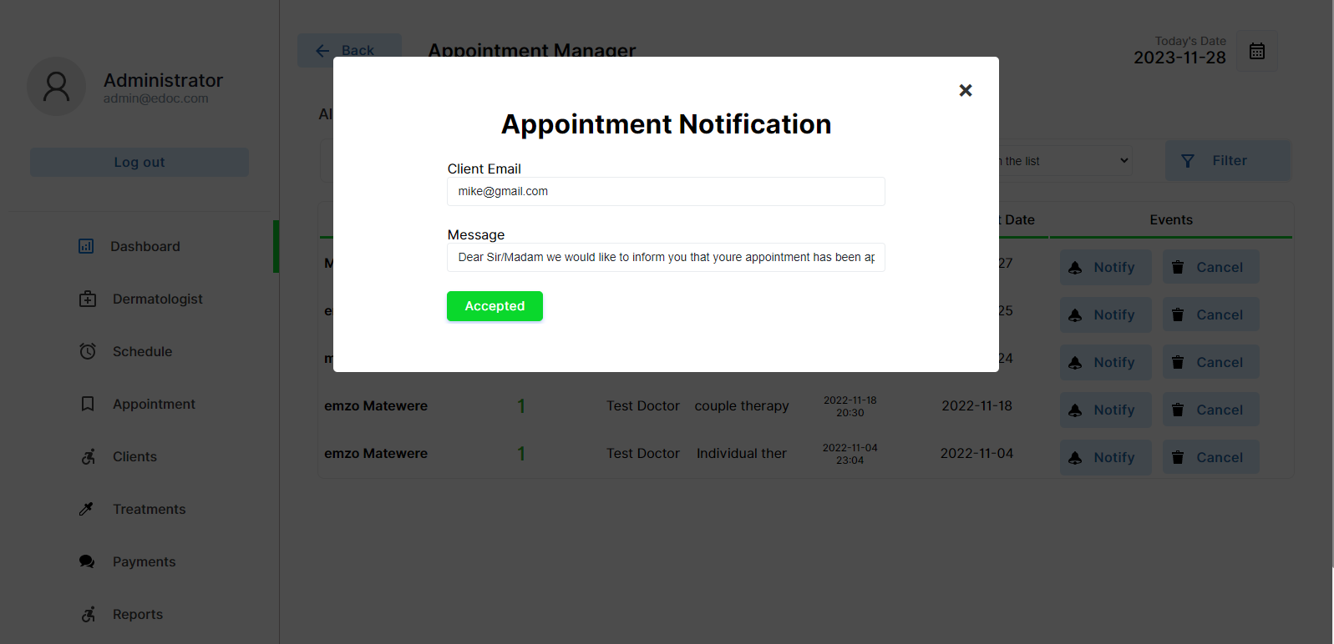

Figure 38 admin send reminder

The client will receive the email

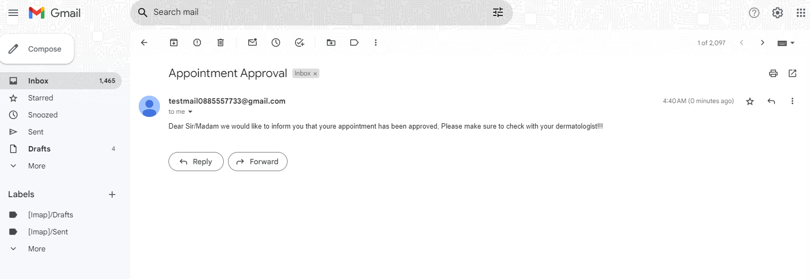

Figure 39 gmail appointment

Admin manage clients

The system also allow the admin to manage all registered clients , the admin can view and delete client accounts.

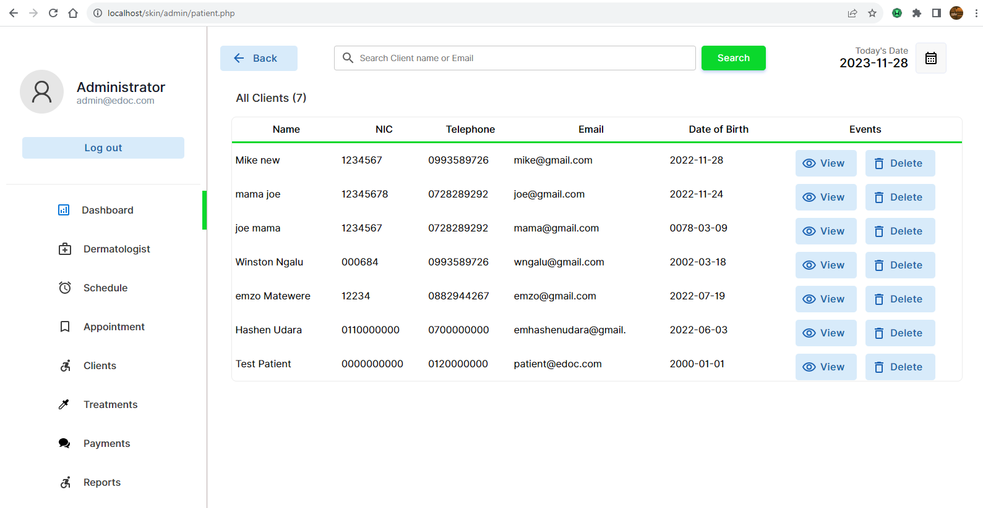

Figure 40 admin manage client

Admin manage treatments

The admin can also view all given treatments.

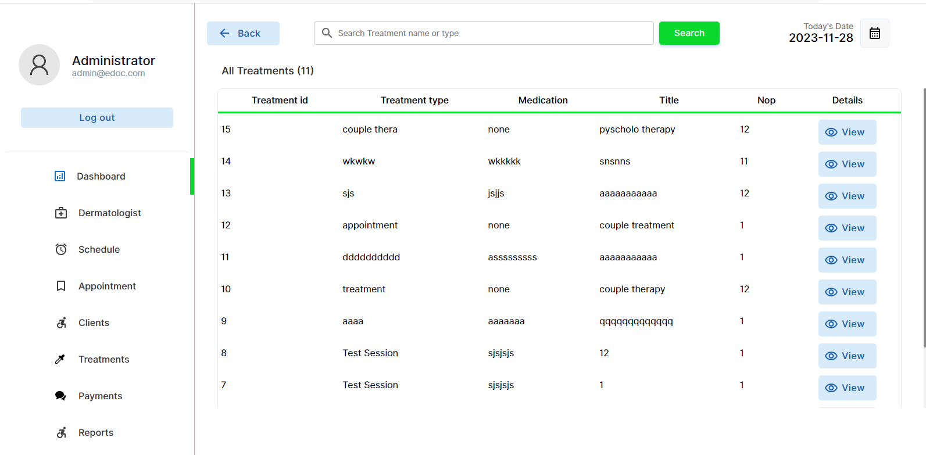

Figure 41 admin manage treatments

Admin manage payments  
The admin is capable of viewing all the payments made by the clients, by navigating to the payment page through the dashboard side menu.

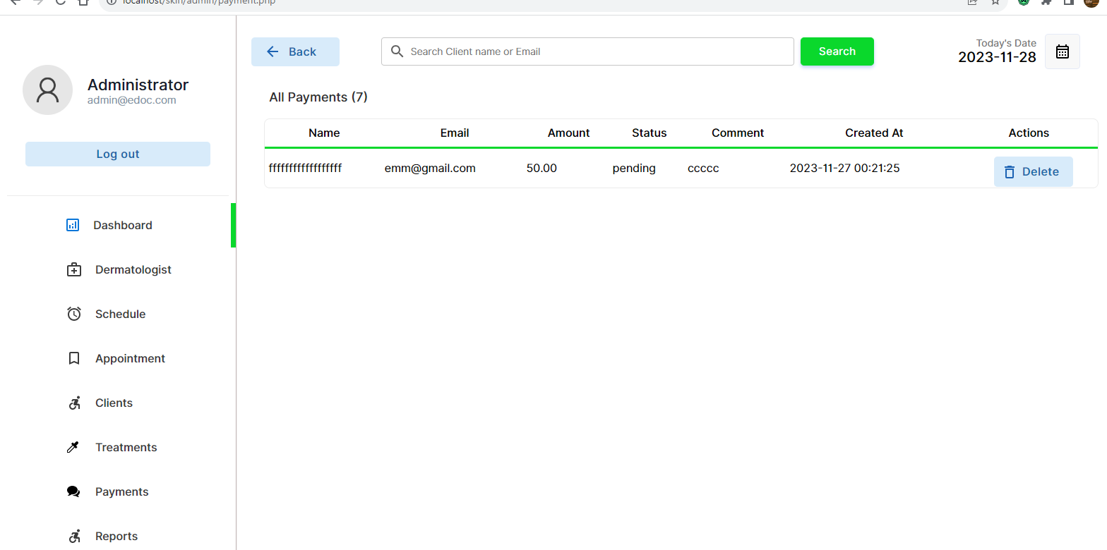

Figure 42 admin payments

Admin generate report

The admin is capable of generating appointment reports. The system will list all the appointments made in the system.

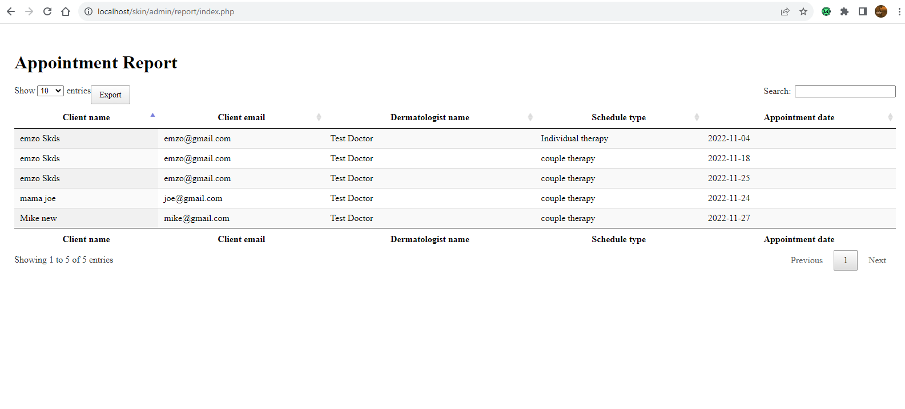

Figure 43 admin generate report

The admin and print out the reports in pdf format.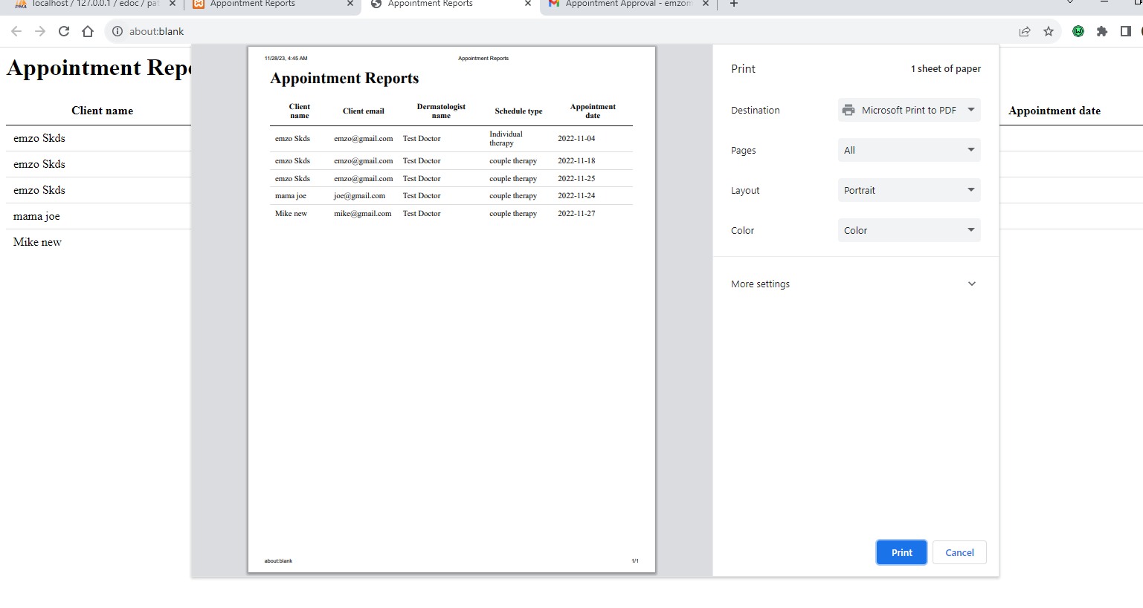

Figure 44 admin pdf report

**Dermatologist user manual**

Login

The admin will create the dermatologist accounts and send them their credentials, the dermatologist will use the details the admin give them to log into the system.

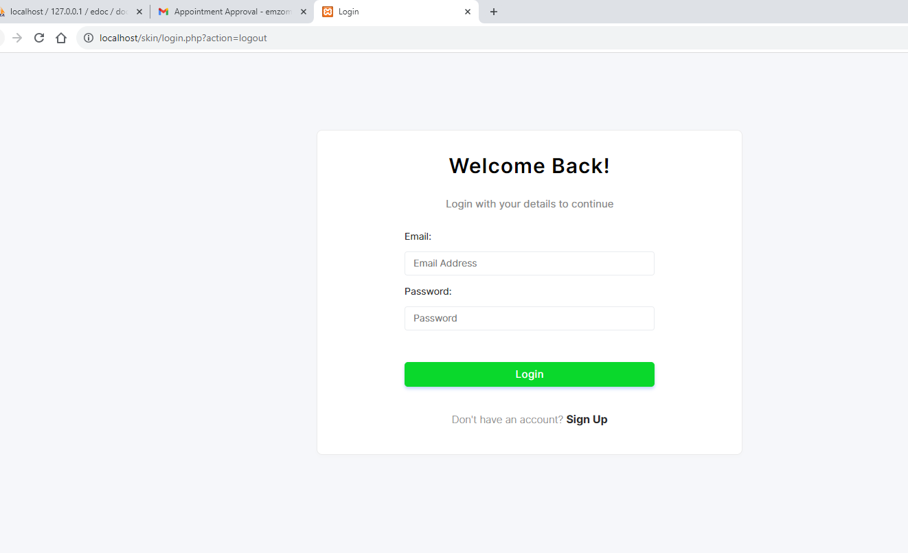

Figure 45 dermatologist login

Dermatologist Dashboard

After logging the system will redirect the dermatologist to their dashboard where they can access and perform their operations faster.

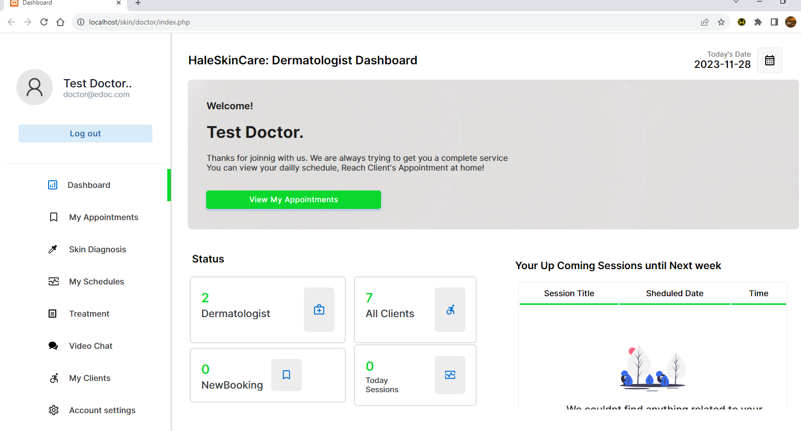

Figure 46 dermatologist dashboard

Dermatologist manage appointments

The dermatologist can manage all the clients that have made an appointment with him. The dermatologist can then processed the appointment to a video chat.

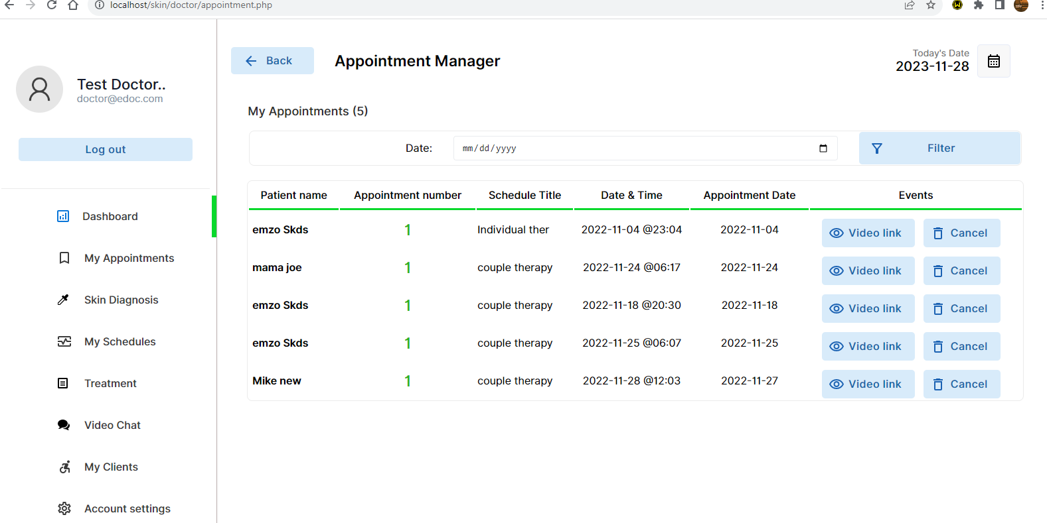

Figure 47 Dermatologist manage appointments

Appointment link

The dermatologist will client on the video link button to send the client and link to the video chat.

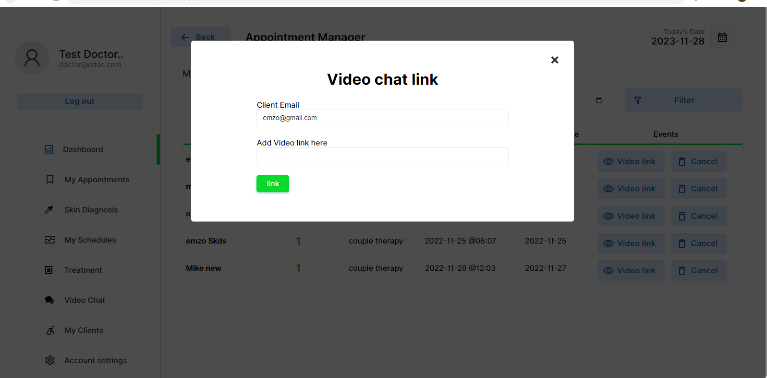

Figure 48 Appointment link

Video chat

The dermatologist will then procced to joining the chat to interact with the client.

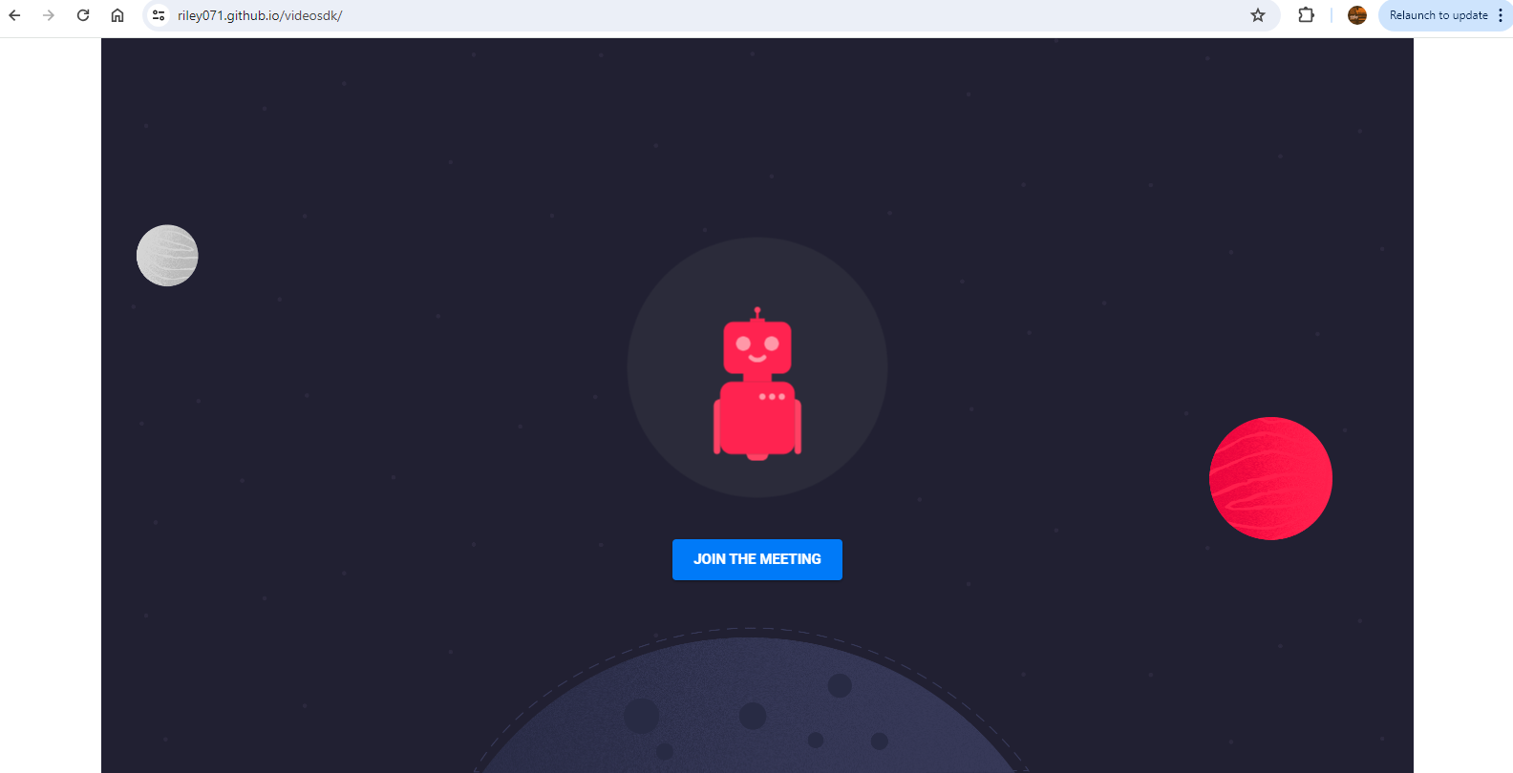

Figure 49 Video chat

The client and dermatologist will then carry out the appointment through the video chat



Figure 50 Video chat 2

Dermatologist manage schedules

The system also allows the dermatologist the manage schedules. The dermatologist can cancel the schedule or view the clients registered to the schedule.

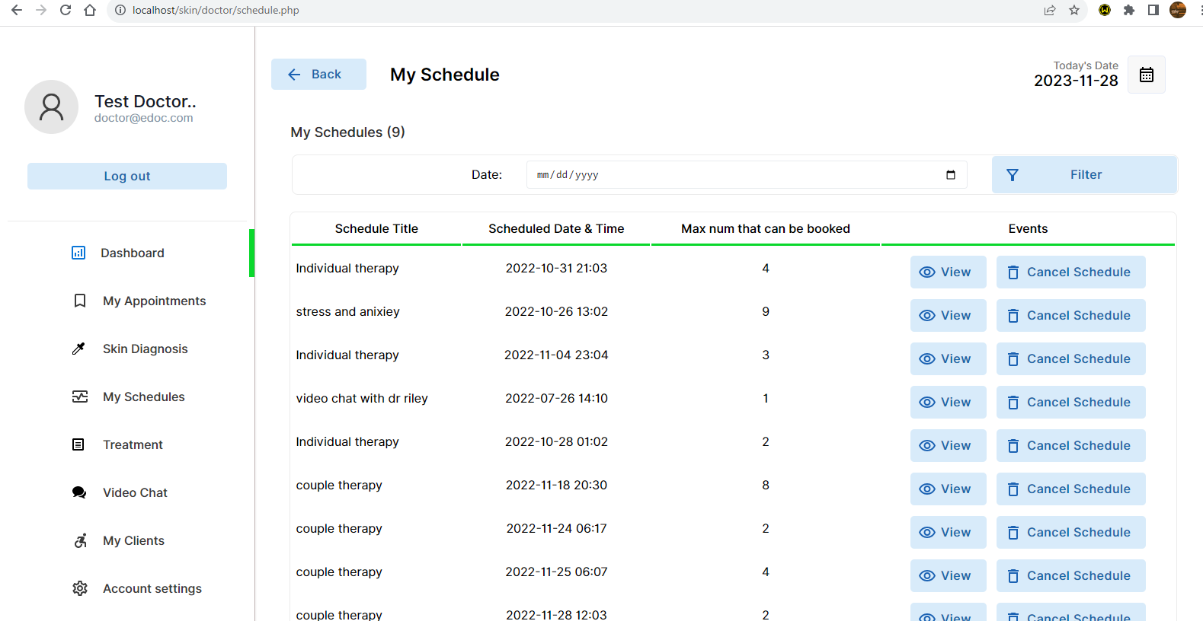

Figure 51 Dermatologist manage schedule

Dermatologist treatment

After the appointment the dermatologist can register the clients treatment plan.

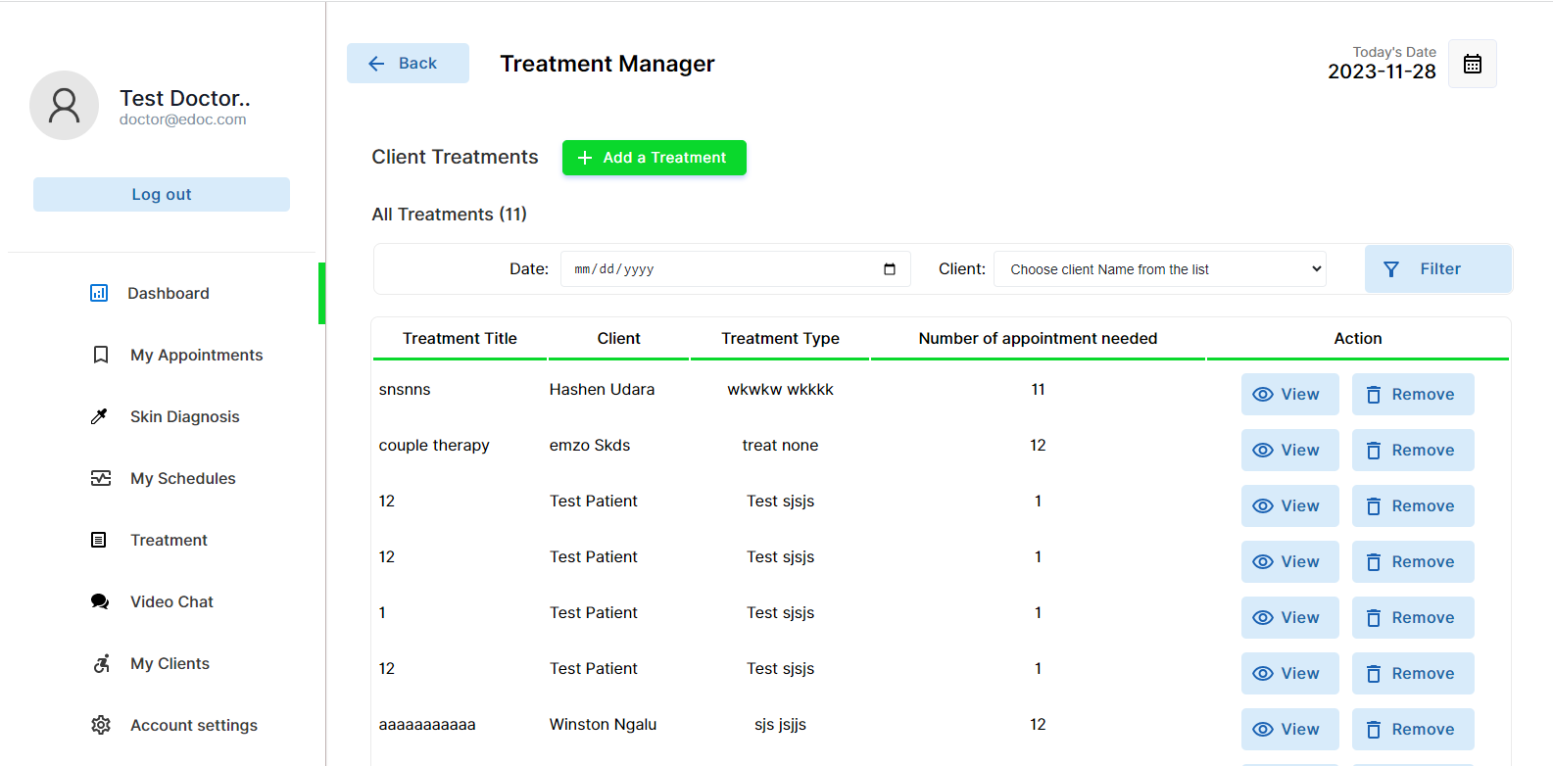

Figure 52 Dermatologist treatment

Add treatment

The dermatologist will add the new treatment plan by filling the form.

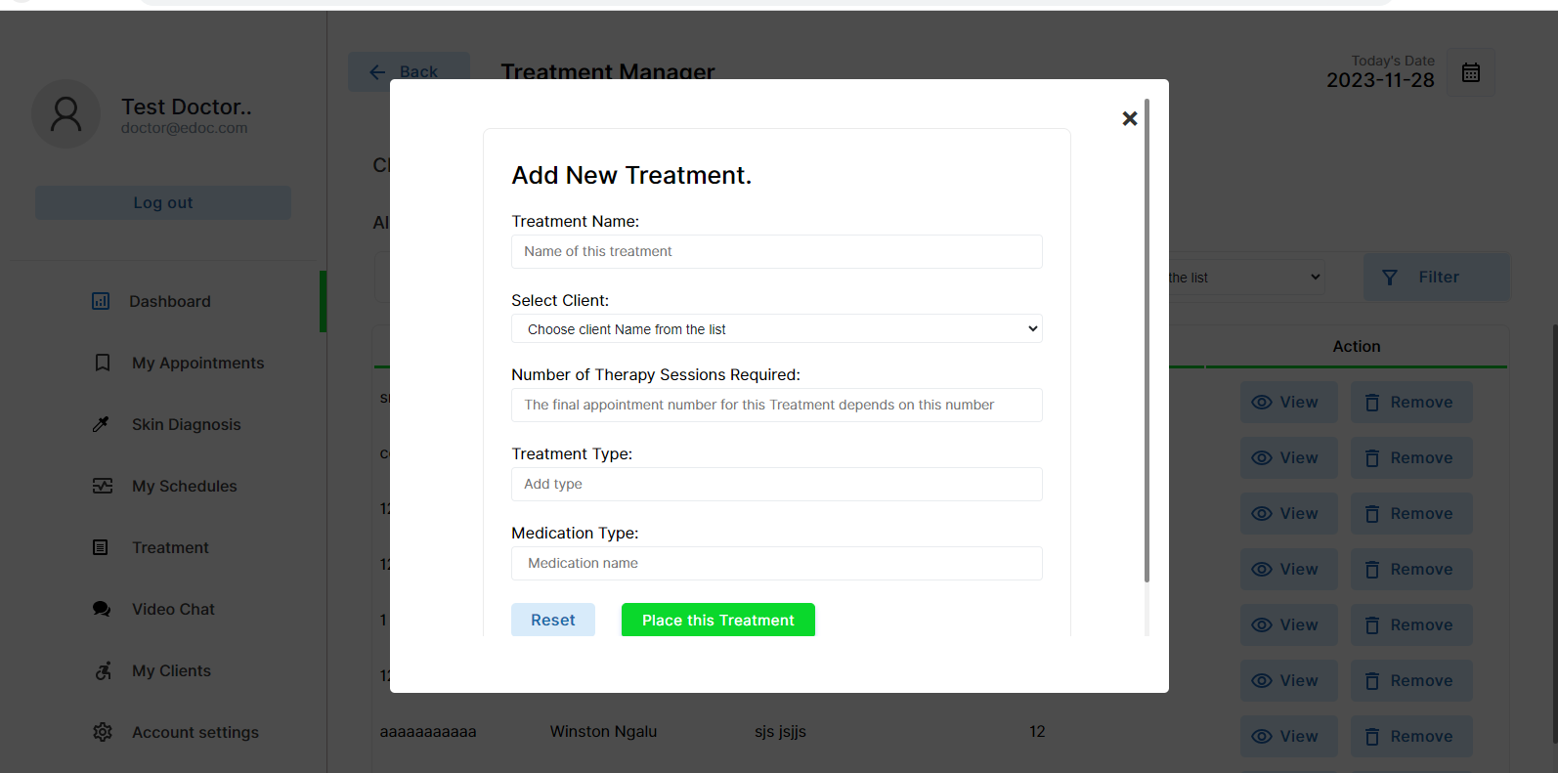

Figure 53 Dermatologist add treatment

Dermatologist manage clients

The system also allows the dermatologist to manage all the clients that have schedule with them before. The dermatologist will be able to view the client details.

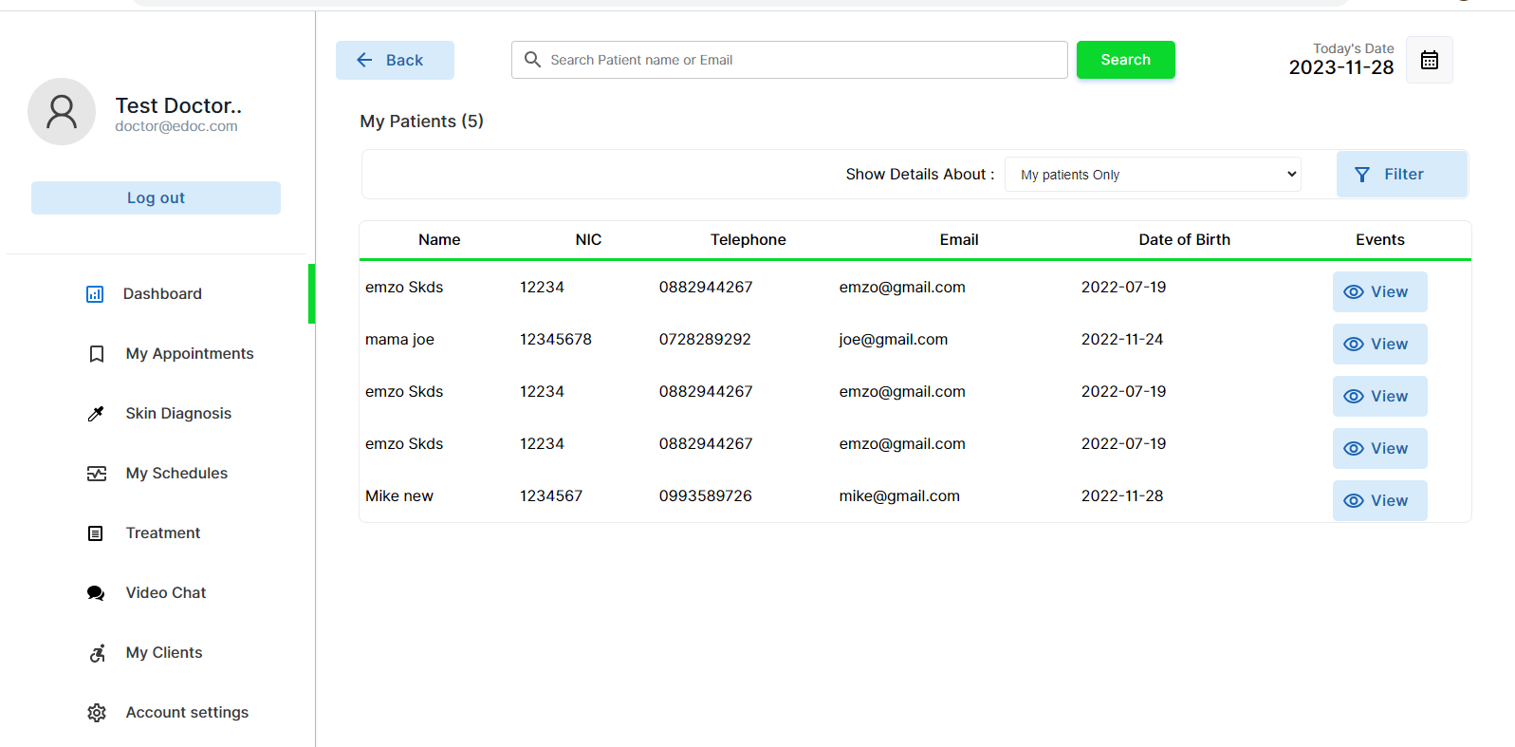

Figure 54 Dermatologist manage clients

Skin diagnosis

Upon receiving the clients images the dermatologist can run a skin image diagnosis.

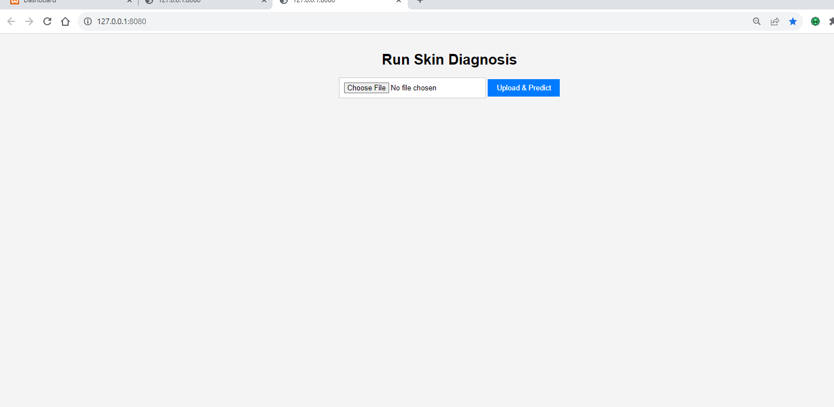

Figure 55 skin diag

Diagnosis prediction

The dermatologist will upload the image the system will then provide with the possible skin condition with the details of the skin image.

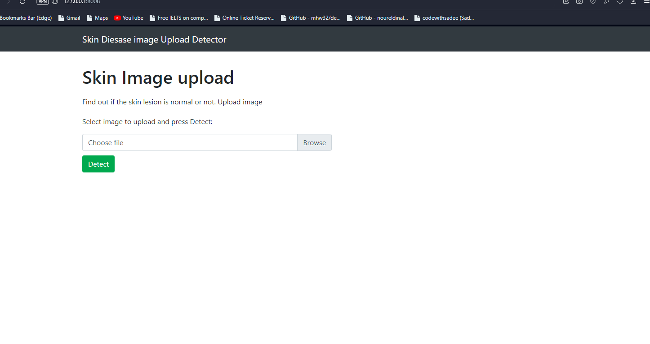

Figure 56 skin prediction results

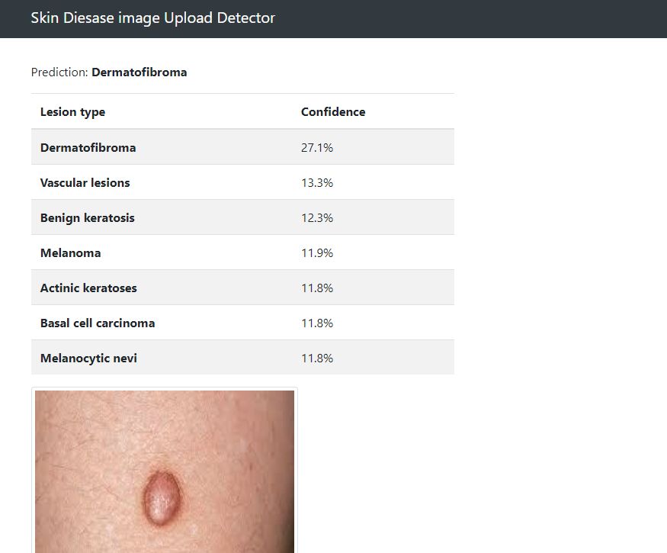

**Client dashboard**

Login

The client is required to create an account inorder for them to be able to log into the system.

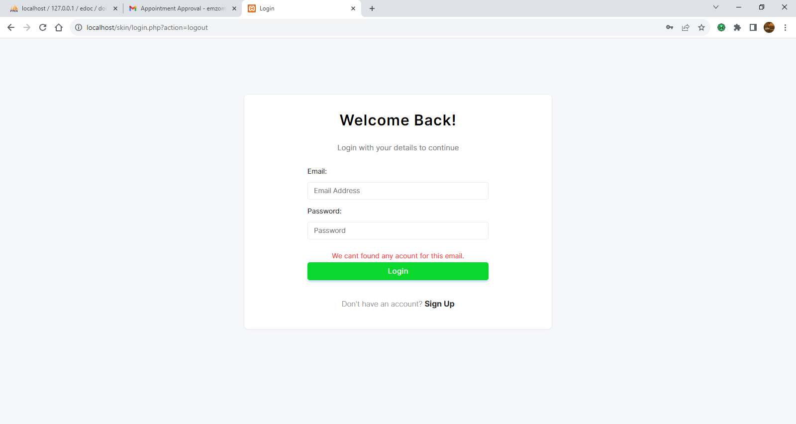

Figure 57 client login

Register

All new clients can fill in the form and register into the system in order for the them to be able to access the client dashboard.

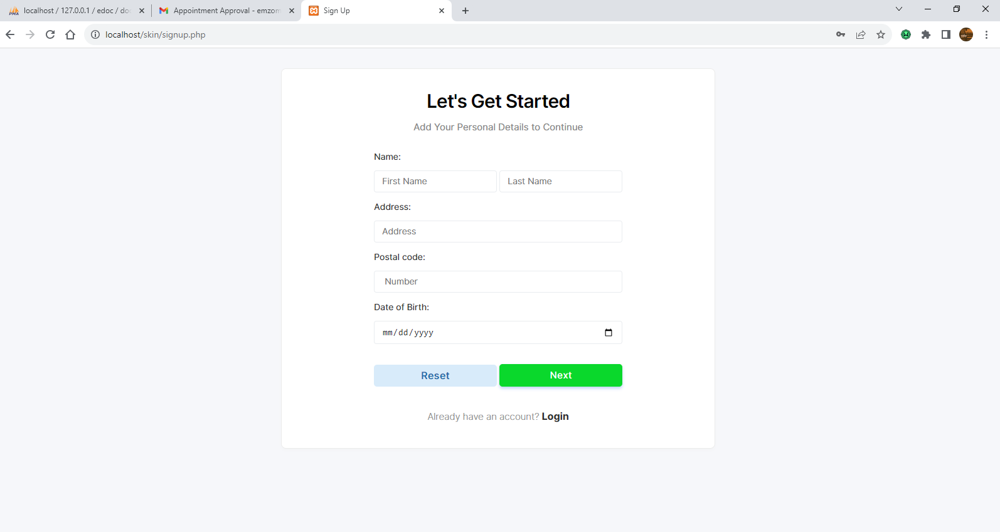

Figure 58 client register

Client dashboard

The logged in client will have access to their dashboard panel where they will be able to carry out operations such as booking an appointment etc. The dashboard also allows clients to navigate through the system.

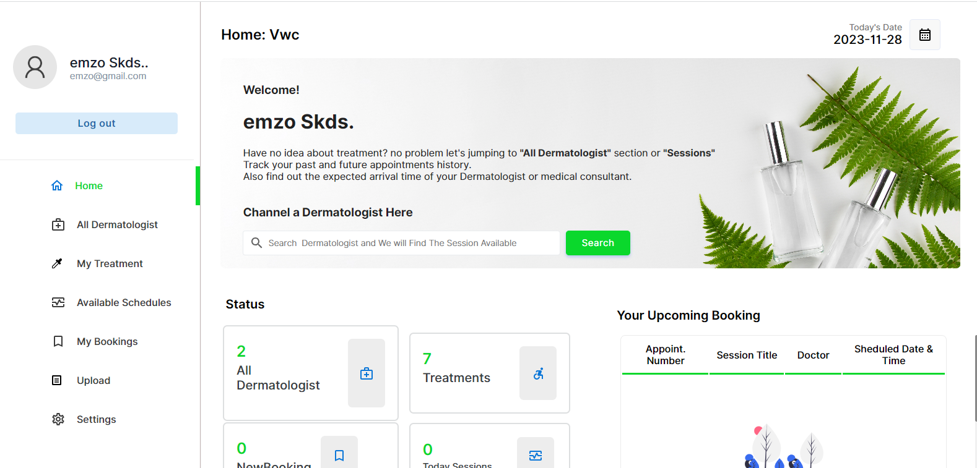

Figure 59 client dashboard

Client treatment

When the client has been given a treatment plan, they will be able to view there treatment plan by navigating to the treatment page using the side bar menu

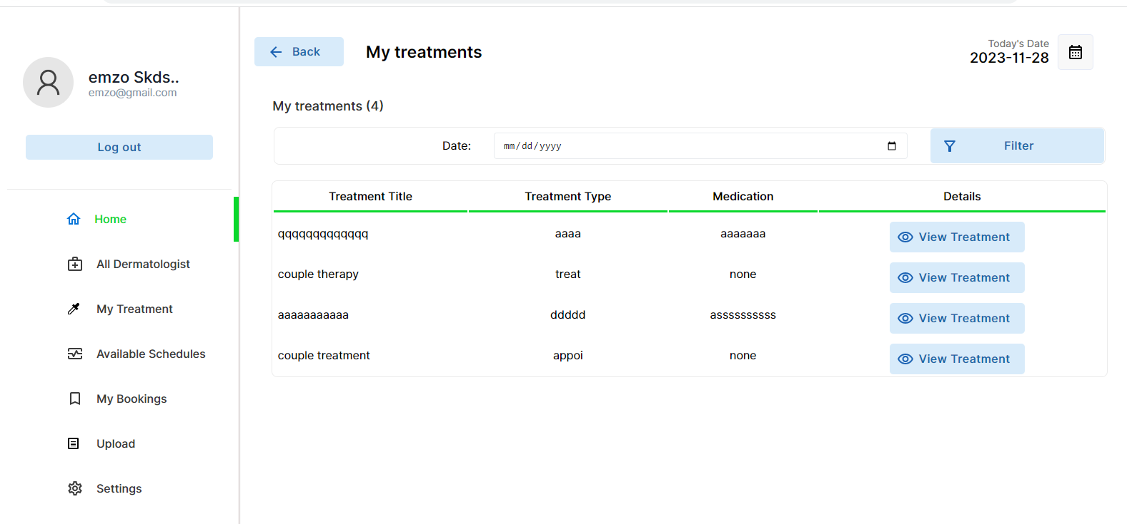

Figure 60 client treatment

Client book appointment

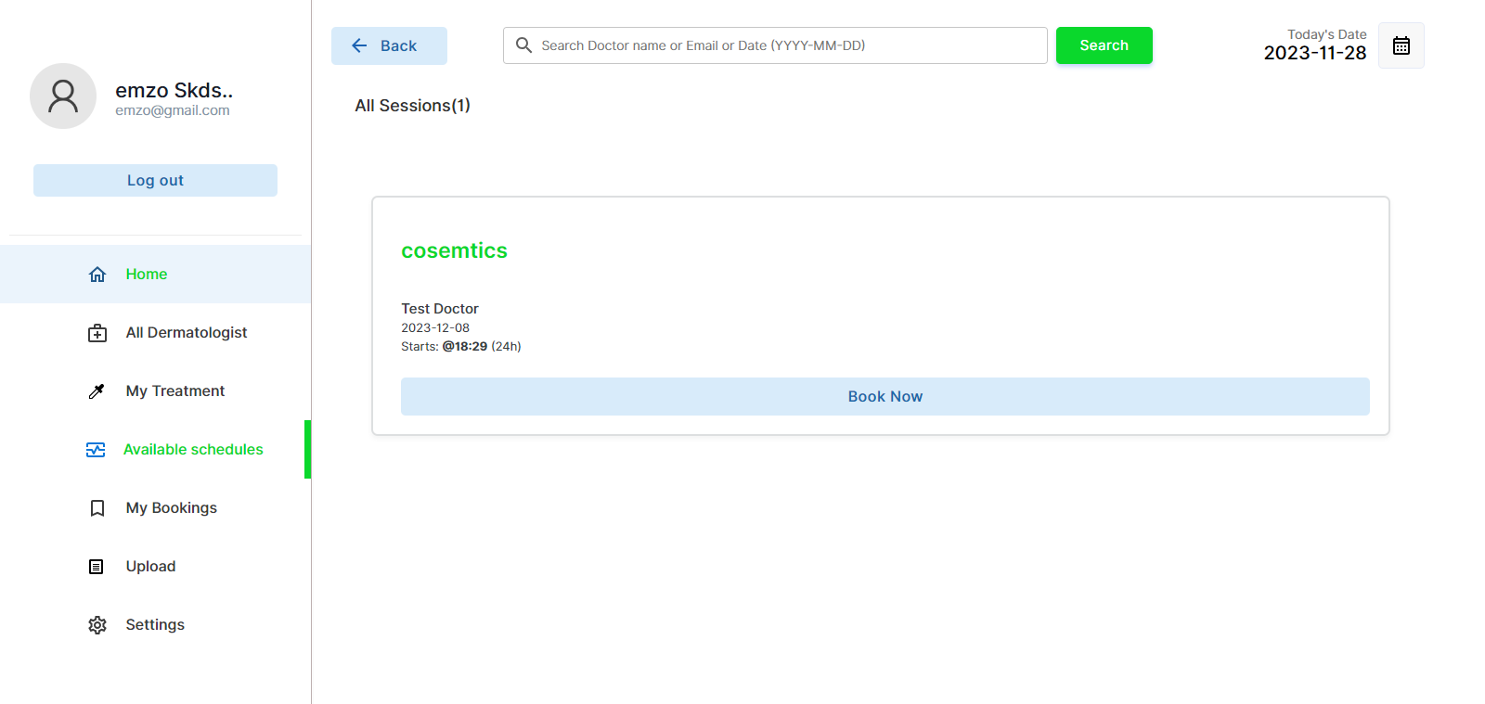

Figure 61 client book

Clients manage bookings

Once the client has made a booking they will be able to manage all their bookings as well as proceed to payment, the client will only make the payment when the booking has been created.

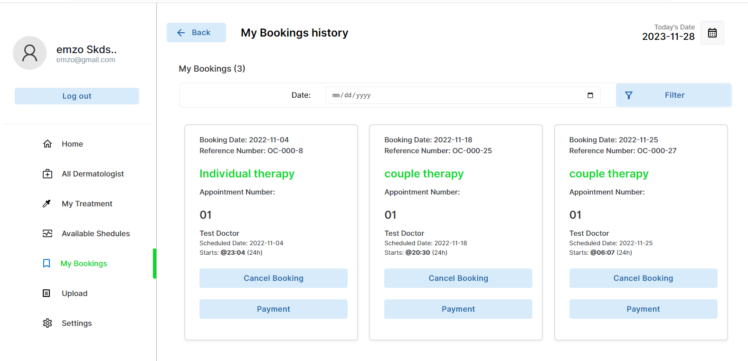

Figure 62 client manage bookings

Upload

On this page the client will be able to send the dermatologist skin pages for the dermatologist to run a diagnosis

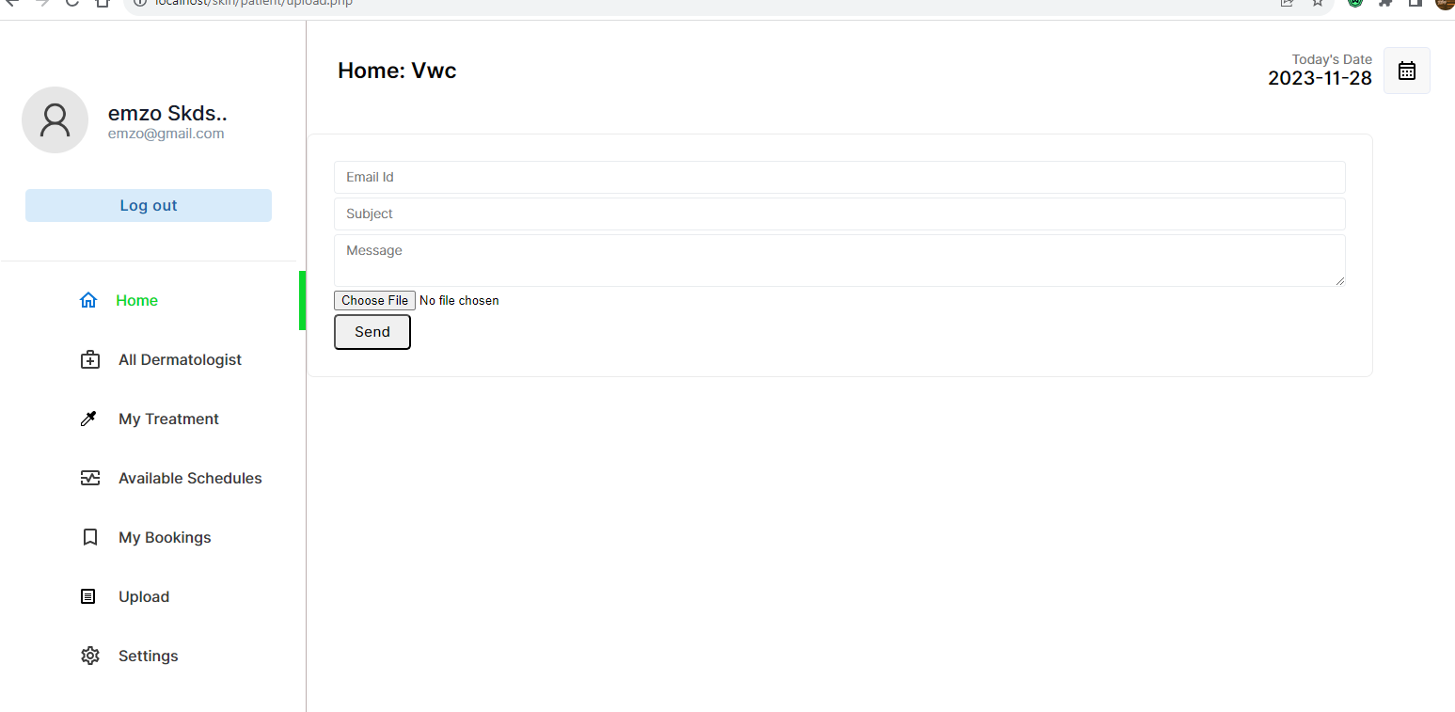

Figure 63 client upload

Client makes payment

In order for the client to make a payment , there required to book for an appointment first, so the client will fill in the form and then continue to pay pal where they will complete the paymet.

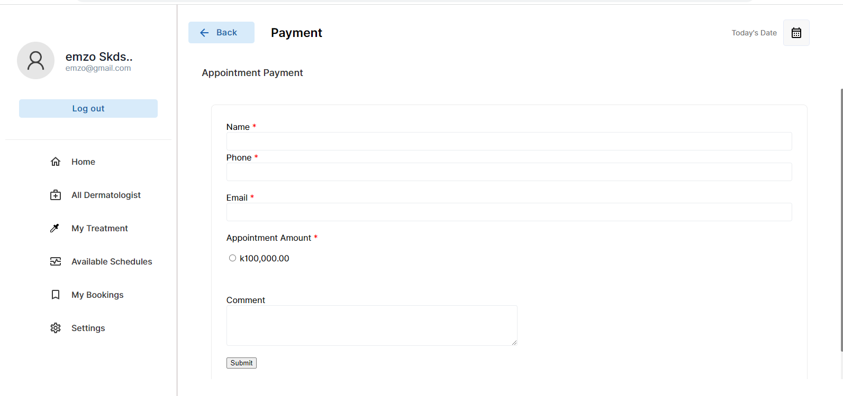

Figure 64 client make payment

The client will add payment description

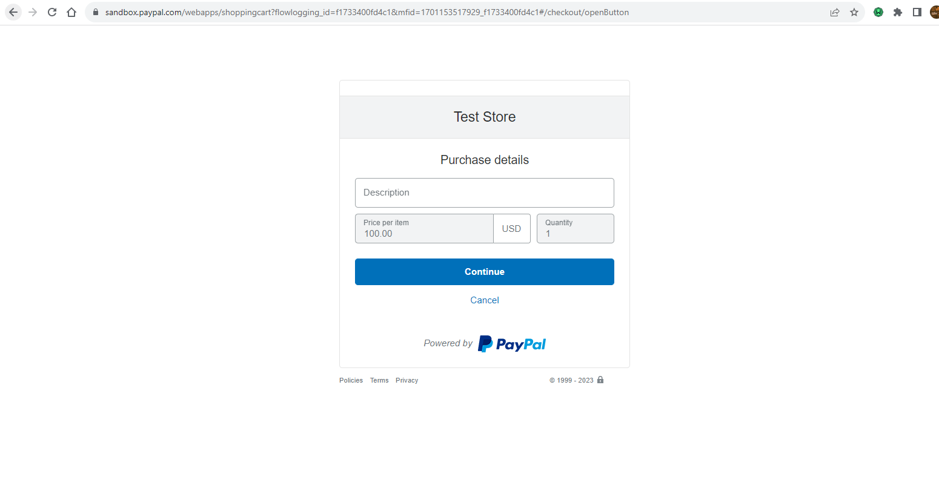

Figure 65 pay pal 1

Client will then log into there pay pal account if there details

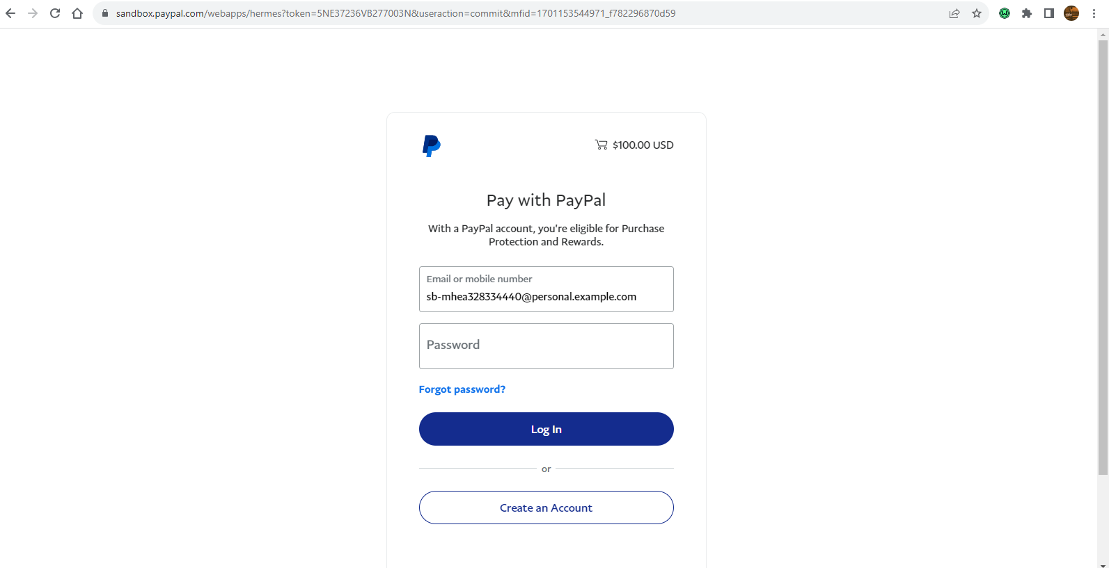

Figure 66 pay pal 2

The client will then finalise the payment

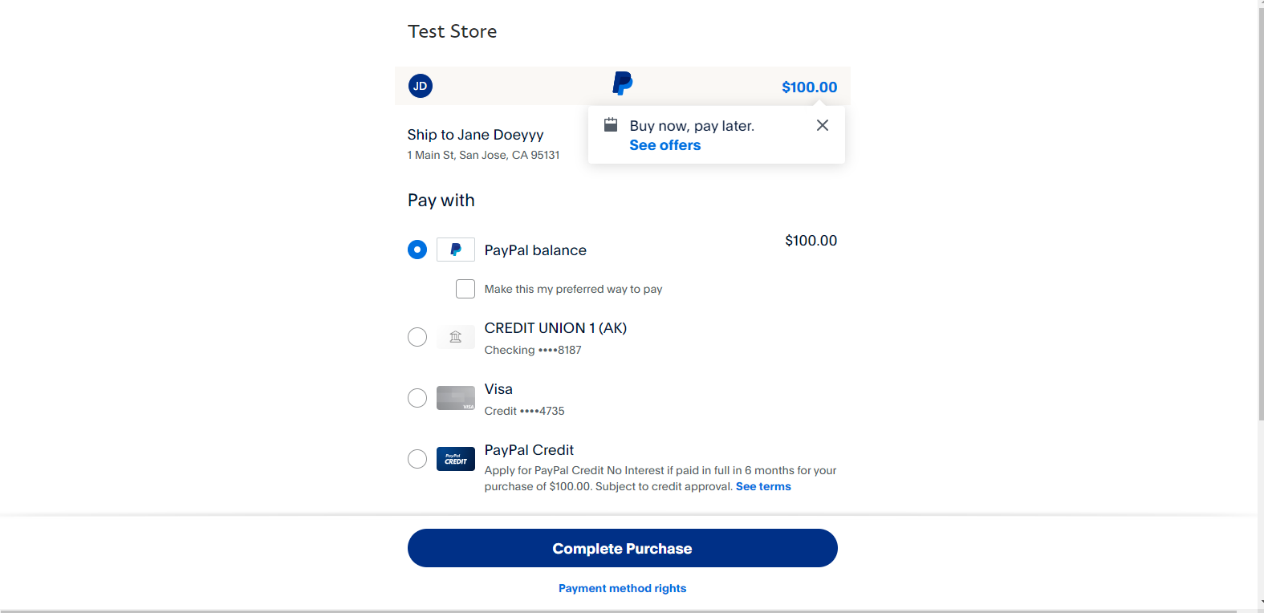

Figure 67 pay pal 3

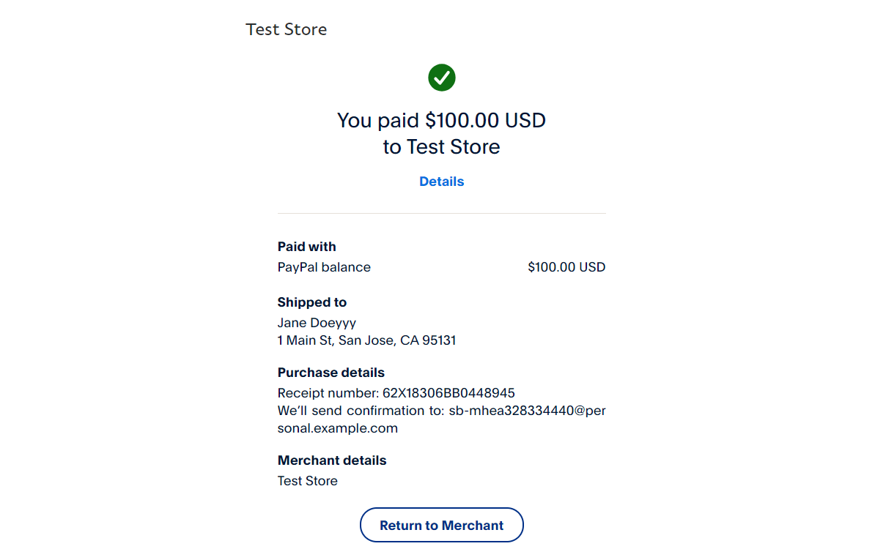

Figure 68 pay pal 4

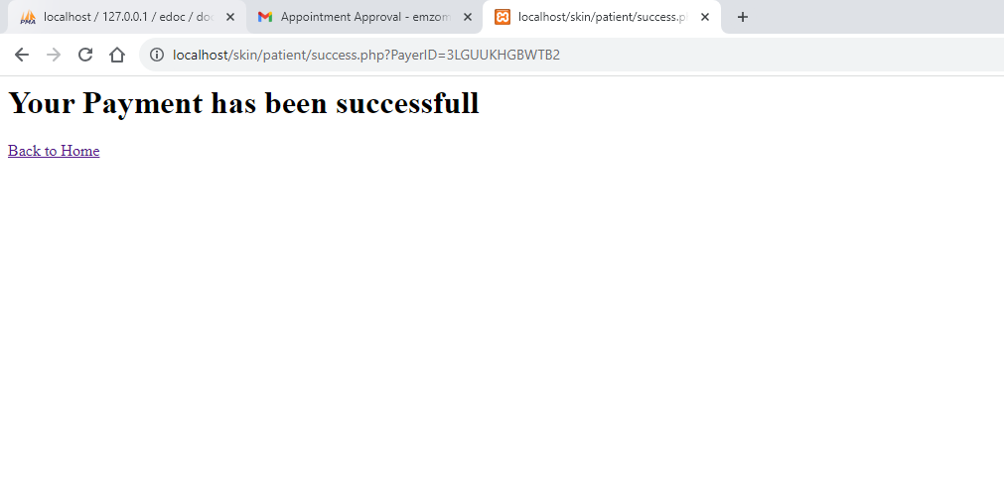

# Appendix D -System Code snippets for the Functional requirements

**Skin diagnosis code**

*# Importing necessary libraries and modules*from __future__ import division, print_function  
import sys  
import os  
import glob  
import re  
from pathlib import Path  
from io import BytesIO  
import base64  
import requests  
  
*# Importing fast.ai Library  
# The fastai library is used for deep learning tasks in this code. Specifically, it is used for image classification tasks.*from fastai import * *# Importing all modules from the fastai library*from fastai.vision import * *# Importing the vision module from the fastai library*from fastai.vision.data import ImageDataBunch *# Importing the ImageDataBunch class from the fastai library  
  
# Importing Flask utilities*from flask import Flask, redirect, url_for, render_template, request *# Importing Flask modules for web application development*from PIL import Image as PILImage *# Importing the Image class from the PIL library for image processing  
  
# Importing Path class from pathlib module*from pathlib import Path  
  
*# Define a Flask app instance*app = Flask(__name__) *# Creating a Flask app instance with the name of the current module  
  
# Setting up file paths and class labels*NAME_OF_FILE = 'model_best' *# Defining the name of the exported model file*PATH_TO_MODELS_DIR = Path('C:/Users/riley/Downloads/SkinCancerDetection-WebApp-master/models') *# Defining the path to the models directory*classes = ['Actinic keratoses', 'Basal cell carcinoma', 'Benign keratosis', *# Defining a list of skin condition classes* 'Dermatofibroma', 'Melanocytic nevi', 'Melanoma', 'Vascular lesions']  
  
*# Function to set up the PyTorch modelcd*def setup_model_pth(path_to_pth_file, learner_name_to_load, classes):  
 *# Setting up the data for the model* data = ImageDataBunch.single_from_classes(  
 path_to_pth_file.parent, classes, ds_tfms=get_transforms(), size=224).normalize(imagenet_stats)  
 *# Creating a learner object with the specified data and model architecture* learn = cnn_learner(data, models.densenet169, model_dir=str(path_to_pth_file.parent))  
 *# Loading the pre-trained model weights and architecture* learn.load(learner_name_to_load, device=torch.device('cpu'))  
 return learn *# Returning the loaded learner object  
  
# Loading the PyTorch model*learn = setup_model_pth(PATH_TO_MODELS_DIR, NAME_OF_FILE, classes) *# Calling the setup_model_pth function to load the model  
  
# Function to encode images to base64 format*def encode(img):  
 *# Converting the image data to a numpy array and then to an 8-bit unsigned integer array* img = (image2np(img.data) * 255).astype('uint8')  
 *# Creating a PIL Image object from the numpy array* pil_img = PILImage.fromarray(img)  
 *# Creating a BytesIO object to store binary data* buff = BytesIO()  
 *# Saving the PIL Image to the BytesIO object in JPEG format* pil_img.save(buff, format="JPEG")  
 *# Encoding the binary data to base64 format and decoding it to UTF-8 format* return base64.b64encode(buff.getvalue()).decode("utf-8")  
  
*# Function to make predictions using the model*def model_predict(img):  
 *# Opening the image file and converting it to an Image object* img = open_image(BytesIO(img))  
 *# Making predictions using the loaded model* pred_class,pred_idx,outputs = learn.predict(img)  
 *# Formatting the prediction probabilities* formatted_outputs = ["{:.1f}%".format(value) for value in [x * 100 for x in torch.nn.functional.softmax(outputs, dim=0)]]  
 *# Sorting the predicted probabilities and class labels* pred_probs = sorted(  
 zip(learn.data.classes, map(str, formatted_outputs)),  
 key=lambda p: p[1],  
 reverse=True  
 )  
  
 *# Encoding the image to base64 format* img_data = encode(img)  
 *# Creating a dictionary containing the predicted class, probabilities, and base64-encoded image* result = {"class":pred_class, "probs":pred_probs, "image":img_data}  
 *# Rendering the result template with the prediction details* return render_template('result.html', result=result)  
  
*# Route for the main page*@app.route('/', methods=['GET', "POST"])  
def index():  
 *# Rendering the index.html template for the main page* return render_template('index.html')  
  
*# Route for uploading images and making predictions*@app.route('/upload', methods=["POST", "GET"])  
def upload():  
 if request.method == 'POST':  
 img = request.files['file'].read() *# Retrieving the uploaded image file* if img != None:  
 preds = model_predict(img) *# Making predictions using the model* return preds *# Returning the prediction results* return 'OK' *# Returning 'OK' if no image is uploaded  
  
# Starting the Flask app*if __name__ == '__main__':  
 port = os.environ.get('PORT', 8008) *# Getting the port from the environment variables or using default port 8008* if "prepare" not in sys.argv:  
 app.run(debug=False, host='0.0.0.0', port=port) *# Running the Flask app on the specified host and port*

**Payment code**

<script src="https://ajax.googleapis.com/ajax/libs/jquery/3.5.1/jquery.min.js"></script>

<?php

/*

 * PayPal and database configuration

 */

// PayPal configuration

define('PAYPAL_ID', 'sb-5i5ys25426193@business.example.com');

define('PAYPAL_SANDBOX', TRUE); //TRUE or FALSE

define('PAYPAL_RETURN_URL', 'http://localhost/skin/patient/success.php');

define('PAYPAL_CANCEL_URL', 'http://localhost/skin/patient/cancel.php');

define('PAYPAL_CURRENCY', 'USD');

// Database configuration

define('DB_HOST', 'localhost');

define('DB_USERNAME', 'root');

define('DB_PASSWORD', '');

define('DB_NAME', 'edoc');

// Change not required

define('PAYPAL_URL', (PAYPAL_SANDBOX == true)?"https://www.sandbox.paypal.com/cgi-bin/webscr":"https://www.paypal.com/cgi-bin/webscr");

?>

**Email code**

<?php

use PHPMailer\PHPMailer\PHPMailer;

use PHPMailer\PHPMailer\SMTP;

use PHPMailer\PHPMailer\Exception;

require 'vendor/autoload.php';

$mail = new PHPMailer(true);

if(isset($_POST['send'])){

print_r($_FILES);

$email = $_POST['email'];

$subject = $_POST['subject'];

$message = $_POST['message'];

    try {

        $mail->SMTPDebug = SMTP::DEBUG_SERVER;

        $mail->isSMTP();

        $mail->Host       = 'smtp.gmail.com';

        $mail->SMTPAuth   = true;

        $mail->Username   = 'testmail0885557733@gmail.com';

        $mail->Password   = 'auufbfxjrsqwdqvg';

        $mail->SMTPSecure = PHPMailer::ENCRYPTION_STARTTLS;

        $mail->Port       = 587;

        $mail->setFrom('haleskincare@gmail.com', 'hale skincare managementsystem');

        $mail->addAddress($email);

        if($_FILES['attachment']['name']!=null){

            if(move_uploaded_file($_FILES['attachment']['tmp_name'],"uploads/{$_FILES['attachment']['name']}")){

        $mail->addAttachment("uploads/{$_FILES['attachment']['name']}");

            }

        }

        $mail->isHTML(true);

        $mail->Subject = $subject;

        $mail->Body    = $message;

        // $mail->AltBody = 'This is the body in plain text for non-HTML mail clients';

        $mail->send();

        echo '<script>alert("Message sent successfully. Thank you!"); window.location.href="upload.php?message_sent";</script>';

    } catch (Exception $e) {

        echo '<script>alert("Message could not be sent. Please try again later.");</script>';

    }

}

**Video chat code**

<html>

<body>

    <div id="root"></div>

</body>

<!-- this is the code for video chat -->

<script src="https://resource.zegocloud.com/prebuilt/crypto-js.js"></script>

<script src="https://resource.zegocloud.com/prebuilt/prebuiltToken.js"></script>

<script src="https://zegocloud.github.io/zegocloud_prebuilt_webrtc/ZegoPrebuilt/index.umd.js"></script>

<script>

const TOKEN = generatePrebuiltToken(2027467606,"ae62d6a2328145b59d922ae729771fd7",'room2','UserID-' + Math.random(),'name'+ Math.random());

const zp = ZegoUIKitPrebuilt.create(TOKEN);

zp.joinRoom({

    container : document.querySelector("#root"),

});

</script>

</html>

**Report code**

<?php

    //include connection file

    include_once("connection.php");

    // initilize all variable

    $params = $columns = $totalRecords = $data = array();

    $params = $_REQUEST;

    //define index of column

    $columns = array(

        0 =>'appoid',

        1 =>'status',

        2 => 'scheduleid',

        3 => 'appodate'

    );

    $where = $sqlTot = $sqlRec = "";

    // getting total number records without any search

    $sql = "select patient.pname,patient.pemail,doctor.docname,schedule.title,appointment.appodate,appointment.appoid,schedule.scheduleid,patient.pemail,schedule.scheduledate,schedule.scheduletime,appointment.apponum from schedule inner join appointment on schedule.scheduleid=appointment.scheduleid inner join patient on patient.pid=appointment.pid inner join doctor on schedule.docid=doctor.docid";

    $sqlTot .= $sql;

    $sqlRec .= $sql;

    $sqlRec .=  " ORDER BY pname";

    $queryTot = mysqli_query($conn, $sqlTot) or die("database error:". mysqli_error($conn));

    $totalRecords = mysqli_num_rows($queryTot);

    $queryRecords = mysqli_query($conn, $sqlRec) or die("error to fetch employees data");

    //iterate on results row and create new index array of data

    while( $row = mysqli_fetch_row($queryRecords) ) {

        $data[] = $row;

    }

    $json_data = array(

            "draw"            => 1,

            "recordsTotal"    => intval( $totalRecords ),

            "recordsFiltered" => intval($totalRecords),

            "data"            => $data   // total data array

            );

    echo json_encode($json_data);  // send data as json format

?>